

Software Engineering Department

Capstone Project Phase B

**Dopamine Booster Game**

(24-2-D-12)

**Supervisor**

Dr. Natali Levi

**Authors**

Roee Barzilai – Roee159@gmail.com

Yuval Hilai – Yuvalos222@gmail.com

February 2025

**Project GitHub Repository:** [Dopamine-Booster-Game](https://github.com/YuvalHilay/Dopamine-Booster-Game)

**Contents**

1 Introduction 4

2 Background and Related Works 6

2.1 Medical Field: ADHD Treatment 6

2.2 Gamification 8

2.3 Current Solutions and Limitations 9

3 Expected Achievements 10

3.1 Outcomes 10

3.2 Success Criteria 11

4 Research and Engineering Process 14

**4.1 Process** 14

4.1.1 Research - Enhancing ADHD Treatment 14

4.1.2 Research – Cross Platform Mobile Development 14

**4.2 Product** 14

4.2.1 Requirements 14

4.2.2 Diagrams and Interfaces 15

5 Tools and Technologies Used 17

6 Verification and Evaluation 20

**6.1 Evaluation** 20

**6.2 Verification** 23

7 Challenges and Solutions 24

7.1 Technical and Engineering Challenges 24

7.2 Personal Challenges and Time Constraints 25

7.3 Consideration in Decision-Making 25

8 Results and Conclusion 26

8.1 Achieving the Project Goals 26

8.2 Reflections on our Development Process 27

9 User Guide Documentation 28

10 Maintenance Guide Documentation 61

11 References 64

12 AI-Tools 65

13 Appendix 66

**Abstract**

Attention-deficit/hyperactivity disorder (ADHD) is a neurodevelopmental disorder affecting millions of individuals worldwide across all age groups. It is characterized by inattention, hyperactivity, and impulsivity, which create significant challenges in daily life, including difficulties in social interactions, work productivity, and academic performance. Traditional treatments, such as medication and behavioral therapies, often face limitations like side effects, high costs, limited accessibility, and difficulties in maintaining long-term symptom management. A key factor underlying these challenges is the dysregulation and deficiency of dopamine, a neurotransmitter essential for concentration, motivation, and impulse control. To address these issues, we developed the “Dopamine Booster Game” a mobile application that leverages neuroscientific research and gamification principles, based on an existing FDA-approved solution (EndeavorRx) to support ADHD symptom management in a more engaging way that emphasizes education and collaboration. The application, developed using Flutter framework, provides an educational platform, interactive quizzes, and a comprehensive system for teachers to create and manage assessments, track student progress and generate reports to evaluate the app’s influence on attention and learning outcomes. The app’s centerpiece is a Unity-developed 3D game designed to enhance focus and motivation. The game incorporates sport-based challenges and mindfulness practices, stimulating dopamine production while promoting a balance between physical activity, mental engagement and restricted gameplay duration. Compatible with both iOS and Android platforms, development is guided by user feedback and iterative testing for optimization to diverse audiences. By integrating medical insights with innovative technology, the project offers a scalable and advanced solution for redefining the globally accepted treatment of ADHD.

**Keywords** **–** Attention-deficit, Hyperactivity disorder, ADHD Treatment, Dopamine Increasing, Personal Medicine, Education, Improving concentration, Research and Development, Mobile Game Therapy.

# **1 Introduction**

Attention-Deficit/Hyperactivity Disorder (ADHD) is a prevalent neurodevelopmental disorder that significantly impairs daily functioning and performance in various settings, including academic, occupational, and social environments [3]. Characterized by persistent patterns of inattention, impulsivity, and hyperactivity, ADHD affects both children and adults, leading to challenges in organizing tasks, following instructions and maintaining focus [2]. These difficulties often result in academic underachievement, workplace issues, and strained relationships.

One major underlying factor contributing to ADHD symptoms is the dysregulation of dopamine, a neurotransmitter crucial for motivation, reward, and pleasure [12]. Dopamine plays a vital role in attention, focus, and impulse control. In individuals with ADHD, dopamine pathways are often less active, making it challenging to experience motivation and reward, which contributes to difficulties in maintaining attention and controlling impulses. Our research on ADHD indicates that the global standards for diagnosis and treatment are tailored to each patient and involve several key steps[1]. First, clinicians must recognize ADHD as a chronic condition and develop a treatment plan that includes educating the child and family about long-term management, involving school staff in collaboration and establishing specific target outcomes. Second, the clinician should assess the effectiveness of different treatment plans, recommending stimulant medications and/or behavioral therapy as appropriate to improve patient outcomes. Finally, regular follow-up is essential, focusing on outcomes and potential side effects, with input gathered from parents, teachers, and the child. In this standard treatment, medications aim to increase dopamine levels in the brain, improving attention and reducing hyperactivity and impulsivity. Behavioral therapies focus on developing organizational skills, time management, and strategies to improve focus. However, these treatments may not be suitable for everyone due to potential side effects, accessibility issues, and personal preferences.

To address the limitations of current treatments and provide an alternative or supplementary method for managing ADHD symptoms, we propose the development of a mobile application titled "Dopamine Booster Game". This project aims to create an interactive game designed to help children with ADHD by leveraging neuroscientific research and innovative game design principles. The primary objective is to stimulate the brain's production of dopamine through engaging and rewarding activities in the game, thereby improving attention and concentration in children with ADHD.

This project falls under both research and development categories, with its significance in its innovative approach to ADHD treatment. The development focuses on creating a functional prototype of the "Dopamine Booster Game," a game-based platform designed to provide an engaging and motivating experience for users. This game aims to improve attention and focus on a fun, interactive way and will be tested and refined based on user feedback and scientific data. At the end of each game session, exercises related to the learned material will appear, allowing us to measure the effectiveness of the game. This approach not only addresses ADHD symptoms but also helps individuals develop transferable skills such as task management, goal setting, and self-regulation.

# **2** **Background and Related Works**

## **2.1 Medical Field: ADHD Treatment**

Attention Deficit Hyperactivity Disorder (ADHD) is one of the most common childhood disorders, affecting approximately 3% to 6% of children globally [1]. It is characterized by symptoms of inattention, hyperactivity, and impulsivity that are inappropriate for a child's developmental level [1]. These symptoms can significantly impact various aspects of a child's life, including their academic performance, family dynamics, and social interactions [1][2]. ADHD treatment has traditionally relied primarily on a combination of medication and behavioral therapy tailored to each individual and involves numerous necessary follow-ups [1].

Medications, including stimulants like methylphenidate and amphetamines, as well as non-stimulants like atomoxetine, are commonly used [4]. These medications work by affecting neurotransmitter levels in the brain, particularly dopamine, which is crucial for attention and impulse control [3]. However, medications often have side effects such as sleep disturbances, appetite suppression, and mood swings [4], leading to a need for non-pharmacological interventions.

Behavioral therapies, such as Cognitive Behavioral Therapy (CBT), focus on modifying negative thought patterns and behaviors [5]. Parent training programs and social skills training are also effective in managing ADHD symptoms [6]. Despite their effectiveness, these therapies require regular sessions with trained professionals, making them costly and time-consuming.

The traditional treatment algorithm for ADHD involves a step-by-step approach that integrates medication and behavioral therapy. The following figure illustrates this algorithm, based on clinical guidelines [1].

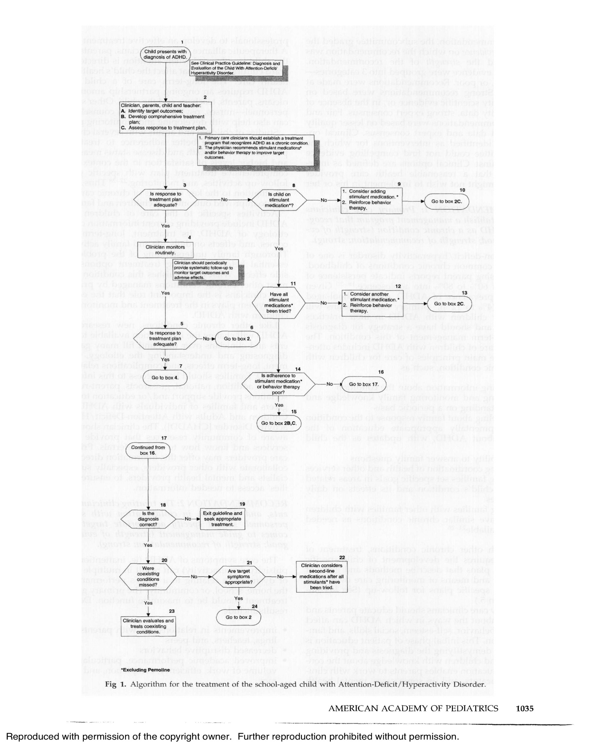

The goal of our project is to create a revolution in the medical field that will offer more accessible and satisfactory treatment in every way to those who need it, by changing the "algorithm" accepted in the world. Our clear vision is to help more children globally, emphasizing their school days in collaboration with the schools and teachers.

## **2.2 Gamification**

Gamification, the application of game design elements in non-game contexts, has rapidly gained traction in various fields, including education, business, and healthcare. This approach uses game mechanics - such as rewards, challenges, and progress tracking - to engage users and motivate behavior change. By incorporating these elements, gamification aims to transform routine tasks and therapeutic activities into more engaging and enjoyable experiences.

In healthcare, gamification has shown promise in improving patient adherence, improving therapeutic outcomes, and promoting healthy behaviors. Interactive games and gamified applications are used to facilitate physical rehabilitation, treat chronic conditions, and promote preventive health measures. These tools engage users by providing real-time feedback, setting achievable goals, and incentivizing progress, which can lead to better health outcomes and increased user motivation.

In the context of ADHD, gamification has been used to address the challenges associated with maintaining attention and controlling impulses. By integrating cognitive challenges and rewarding experiences into gameplay, game-based interventions can support the development of skills crucial to ADHD management. Research shows that such approaches can effectively improve attention, working memory and impulse control and are a valuable complement to traditional treatment methods [7].

The potential of gamification in ADHD treatment is significant. Gamified interventions can increase user engagement and motivation, crucial for adherence to treatment protocols [10]. Games designed to stimulate dopamine production can directly address the neurotransmitter dysregulation seen in ADHD, providing a targeted method for symptom management [11]. Research indicates that digital therapeutics, including cognitive training games and neurofeedback, can produce significant improvements in attention and executive functioning in individuals with ADHD [9].

**Potential Risks of Excessive Mobile Game Use**

While gamification offers significant benefits, it is important to be aware of potential risks associated with overusing mobile games. Increased screen time can lead to issues such as decreased physical activity, disrupted sleep patterns and increased screen addiction. Excessive gaming can also impair cognitive development, particularly in children, by reducing time spent on other critical activities such as academic learning and social interactions [7]. Additionally, long-term overuse of

mobile games have been linked to mental health concerns like anxiety and depression due to social isolation and overdependence on digital platforms [9].

## **2.3 Current Solutions and Limitations**

In recent years, digital interventions have emerged as promising supplementary treatments for ADHD. One notable example is EndeavorRx, an FDA-approved video game designed to treat pediatric ADHD by targeting neural systems involved in attention through sensory stimuli and motor challenges [7]. Other mobile applications like Cogmed and BrainBeat offer cognitive training exercises aimed at improving attention and working memory [8]. Biofeedback and neurofeedback methods use real-time monitoring of physiological signals to teach individuals how to regulate their brain function and improve attention [9].

Research consistently highlights dopamine's critical role in ADHD. Dopamine dysregulation is linked to core symptoms such as inattention, impulsivity, and hyperactivity [12]. Interventions that effectively increase dopamine levels are therefore highly relevant for ADHD treatment. The success of digital health solutions like EndeavorRx demonstrates the potential of this approach, providing scalable, cost-effective, and easily accessible treatment options [7].

However, EndeavorRx has certain limitations, such as: requires certain devices (iOS-based tablets) and internet access that may not be available to all users at all times. EndeavorRx can also be expensive for some families, as it may require a prescription and ongoing subscription fees. Another concern with mobile game is the potential for overuse, as there is a risk of children spending excessive time on screens, leading to issues like decreased physical activity, disrupted sleep, or increased screen addiction. Additionally, some children might experience frustration or stress if they struggle with EndeavorRx's tasks. Finally, EndeavorRx is designed for children aged 8-17, limiting its applicability for younger children or adults with ADHD.

These advantages suggest that while EndeavorRx can be a helpful tool for managing ADHD symptoms, it may not be suitable for everyone. The "Dopamine Booster Game" addresses these limitations, offering an inclusive, cost-effective, and engaging solution for ADHD treatment.

In conclusion, while existing treatments for ADHD, including medication and behavioral therapy, are effective, they have limitations that necessitate the development of innovative interventions. Digital therapeutics and gamification offer promising new avenues for ADHD treatment. The "Dopamine Booster Game" builds on this foundation by targeting dopamine production through interactive gameplay, providing a scientifically grounded and engaging tool to improve attention and concentration in children with ADHD.

# **3 Expected Achievements**

## **3.1 Outcomes**

The "Dopamine Booster Game" project aims to create a comprehensive and innovative solution for managing ADHD symptoms. Our project will focus on developing several key achievements and products that will collectively form an effective and engaging intervention for individuals with ADHD. The following outlines the expected achievements of our project:

**Interactive Mobile Application**

The primary product of our project will be a fully functional mobile application available on multiple platforms (iOS, Android). This application will be designed to support a wide range of devices, ensuring accessibility for all users. The game will incorporate engaging and interactive activities specifically designed to stimulate dopamine production. These activities will be based on neuroscientific research and tailored to address the core symptoms of ADHD, such as inattention, impulsivity, and hyperactivity. The application will feature a user-friendly interface with intuitive navigation, making it accessible for children, teenagers, and adults with ADHD.

**Dopamine-Stimulating Game Mechanics**

The game will utilize specific mechanics to stimulate dopamine production, such as reward systems, progressive challenges, and goal-setting elements. These mechanics will be integrated into the gameplay to ensure a motivating and rewarding experience for users. Activities within the game will include tasks that require sustained attention, problem-solving, and impulse control. As part of the application in between game sessions, students will participate in solving exercises assigned to them by their teacher, designed to improve their problem-solving skills and cognitive reaction times. By incorporating game mechanics aimed at quick decision-making and accuracy, the game aims to reduce thinking time and improve the correctness of answers, ensuring that players not only enjoy the process, but also achieve measurable improvements in their cognitive performance and have a desire to continue improving by using our platform.

**Personalized User Experience**

The application will include a customized user experience, adapting the difficulty and nature of tasks based on individual performance and progress. This personalization helps maintain user engagement and better student-teacher interaction, ensuring activities are appropriately challenging for each user. As students progress through the game and show improvement, the tasks become more challenging. Those who struggle with certain exercises receive adjustments to create a balanced and motivating learning environment and make it easier for teachers and students to achieve their goals and receive a proper assessment.

**Integration of Physical Activity**

To address the potential risks of excessive screen time, the game monitors and limits play time overall and for each gaming session while incorporating elements of physical activity. Certain tasks will require physical movement, promoting a healthy balance between screen-based activities and physical exercise. These physical tasks will be designed to be fun and engaging, ensuring that users enjoy the activities while also benefiting from increased physical activity.

## **3.2 Success Criteria**

The success of the "Dopamine Booster Game" project will be measured based on several key criteria

**Improvement in ADHD Symptoms**

Success is determined by measurable improvements in ADHD symptoms, particularly inattention, impulsivity and hyperactivity. These improvements will be assessed through a combination of pre- and post-intervention assessments using standardized ADHD rating scales, such as the *ADHD Rating Scale-IV* [13]. Additionally, exercises related to the game's cognitive training activities are incorporated at the end of each session. The results of these exercises provide quantifiable data about the user's progress over time and provide immediate feedback on attention and focus improvements.

In addition, at the beginning of the school year, teachers complete a detailed observation questionnaire (see Appendix A) that serves as a baseline for each student. Teachers then complete the same questionnaire at key intervals throughout the school year to track behavioral changes and academic performance. This combination of game-based assessments (per session and total usage) and teacher-reported data provides a robust framework for evaluating the effectiveness of the "Dopamine Booster Game" in improving ADHD symptoms.

**User Satisfaction**

User satisfaction will be gauged through surveys and feedback forms, focusing on the game's usability, enjoyment, and perceived benefits. Positive feedback and high satisfaction ratings will be key indicators of success.

**Accessibility and Inclusivity**

The application’s ability to support multiple devices and platforms, along with its inclusivity for different age groups and demographics, will be crucial for its success. Widespread accessibility will demonstrate the game’s potential to reach a broad audience.

**Scalability and Testing**

The application's scalability, including its potential for widespread adoption in various settings (e.g., schools, clinics, and homes), will be a significant measure of success. To further ensure scalability and adoption, we plan to design school experiments to evaluate the game's effectiveness in real-world educational settings. These experiments will involve teachers and students in a controlled setting where the game will be introduced as part of the classroom routine. After a few minutes of gameplay, teachers will observe and provide feedback on whether the game helps improve students' attention and concentration during class activities. This feedback will be crucial in refining the development of the game's design and functionality to better serve its intended purpose, until the stage where it is ready to move to a clinical trial.

**Recognition and Adoption in the medical field**

Gaining recognition and publication in the medical field is essential for the success of the "Dopamine Booster Game". This will involve rigorous clinical trials, peer-reviewed publications, and endorsements from leading medical professionals and institutions. Integrating the game into existing treatment plans will ensure its acceptance as an effective ADHD intervention. By incorporating this digital tool into the traditional treatment, we aim to revolutionize ADHD management, providing a more updated and accessible solution. The following figure illustrates the integration of our game into the current ADHD traditional treatment algorithm to suggest a new and improved algorithm.

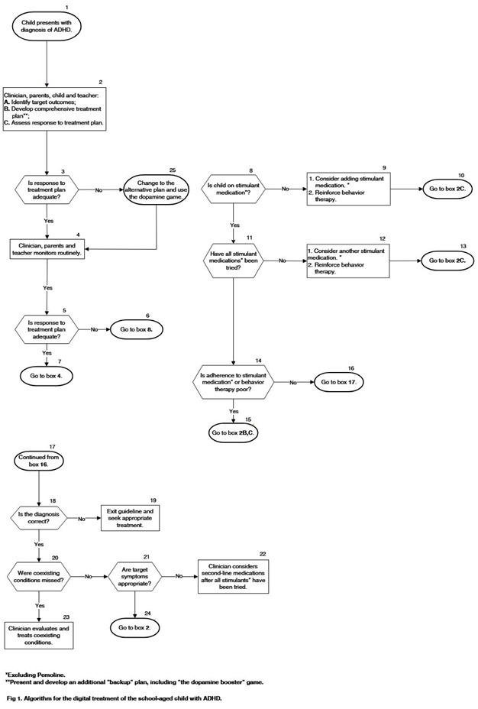Figure 2: Suggested Algorithm for treatment of the school-aged child with ADHD.

By achieving these goals, the "Dopamine Booster Game" project will provide a scientifically grounded, engaging, and accessible tool for managing ADHD symptoms, offering a valuable alternative or supplement to traditional treatments and thus fulfilling our vision and expanding it to another target audience.

# **4 Research and Engineering Process**

The information gathering and learning process until now was mostly split between the largest parts of the project: theoretical knowledge, concerned with understanding what is ADHD and the practical considerations of how to approach to global mobile development from a software and hardware perspective.

## **4.1 Process**

### **4.1.1 Research - Enhancing ADHD Treatment**

In this initial phase of the project, our team focused on developing the theoretical framework for our software solution. This involved conducting a thorough literature review to identify existing methods and tools for ADHD management and digital interventions. Through this review, we established the foundational knowledge necessary for the design of our innovative mobile application, the "Dopamine Booster Game."

Based on our research findings, we developed a conceptual model for our software solution, outlining the main features, algorithms, and methodologies that will be implemented to stimulate dopamine production and improve attention and concentration in users. Additionally, we formulated a detailed project plan, delineating key milestones and deliverables essential for the development process.

To plan our development, we identified the technical requirements for our software solution, including hardware and software specifications, data storage and user interface design. This information guided our selection of appropriate tools and technologies, prioritizing factors such as compatibility, scalability, and ease of use.

Throughout this theoretical development process, we regularly reviewed and evaluated our progress, using insights from our project advisor and literature review to refine our conceptual model and project plan. By the end of this phase, we aimed to have a well-defined and comprehensive theoretical framework for our software solution, establishing a solid foundation for the subsequent phases of the project.

**Initial Research/Experiments**

We explored various game mechanics and interactive designs that could effectively engage users while promoting cognitive training. Although no prototypes were developed at this stage, our research laid the groundwork for future design and implementation efforts.

These initial explorations revealed promising avenues for creating engaging gameplay experiences that could potentially lead to significant improvements in ADHD symptom management.

**Research Challenges**

Several challenges need to be addressed to achieve the expected outcomes:

**User Engagement:** Creating a game that maintains user interest and encourages regular engagement poses a significant challenge. It is crucial to balance fun and educational elements to ensure sustained interaction.

**Algorithm Selection:** Identifying the most suitable algorithms for personalized user experiences is essential. The chosen algorithms must adapt to individual performance and preferences while providing effective dopamine stimulation.

**Complex User Interface Design:** Developing an intuitive and accessible user interface that provides to a broad age range and varying levels of technological proficiency requires careful consideration and design iterations.

By addressing challenges related to user engagement, algorithm selection, and user interface design, the proposed solution intends to provide individuals with ADHD a powerful tool for managing their symptoms effectively.

### **4.1.2 Research – Cross Platform Mobile Development**

In this section, the focus is on researching and identifying the optimal approach for developing a cross-platform mobile application for the "Dopamine Booster Game". Cross-platform development is essential for ensuring the app is accessible to a broad user base across different devices and operating systems, including iOS and Android.

**Definition of Cross-Platform Mobile Development**

Cross-platform mobile development refers to the process of creating software applications that are compatible with multiple mobile operating systems from a single codebase. Unlike native development, where separate codebases are maintained for each platform (iOS and Android), cross-platform development uses frameworks and tools that enable developers to write shared part of code once and deploy it across various platforms. Platform refers to the type of processor (CPU) or other device hardware on which an operating system (OS) or application runs, the type of OS, or a combination of the two. This approach not only reduces development time and costs but also simplifies maintenance and updates. Popular cross-platform frameworks include Flutter, React Native, and Xamarin, each offering unique features and advantages tailored to different project needs.

When developing a 3D mobile game, several cross-platform solutions are available. Popular frameworks include Unity, which is widely used for 3D game development due to its robust engine and extensive support for physics, rendering, and animations across platforms like iOS and Android. Unreal Engine is another powerful option, known for delivering high-quality graphics but often more resource intensive. React

Native and Flutter offer cross-platform capabilities for general app development but lack native 3D rendering support. To leverage the strengths of both worlds, our solution integrates Unity for handling 3D game mechanics, while Flutter is used to build the user interface and manage non-3D features. This hybrid approach allows us to benefit from Unity's advanced 3D capabilities while taking advantage of Flutter's fast, responsive UI and native-like performance across multiple devices. By combining these technologies, we ensure a seamless and optimized experience for users, regardless of platform.

## **4.2 Product**

### **4.2.1 Requirements**

**Functional:**

|  |  |
| --- | --- |
| 1 | The system allows users to sign up, log in, and log out. |
| 2 | The system supports third-party authentication login (e.g., Google, Facebook). |
| 3 | The system allows users to track their progress and performance over time. |
| 4 | The system includes reward activities, progressive challenges, and goal-setting elements. |
| 5 | The system adapts the difficulty of tasks based on individual performance set by the teacher. |
| 6 | The system includes tasks that require sustained attention, problem-solving, and impulse control. |
| 7 | The system includes elements that encourage physical activity, such as tasks requiring physical movement. |
| 8 | The system provides daily feedback on user performance. |
| 9 | The system includes a reward system to motivate and engage users. |
| 10 | The system collect data on user performance and engagement. |
| 10.1 | The system analysis this data to provide personalized recommendations. |
| 11 | The system provides a separate interface for teachers or parents to monitor the progress of the children using the app. |
| 12 | The system allows teachers or parents to provide feedback on the game's impact on the users. |
| 13 | The system allows to add questions and answers by the teacher interface. |
| 14 | The system allows student to answer and submit answers for teacher assignment |
| 15 | The system allows automatic feedback of the grade of student assignments for the teacher. |

**Non-Functional:**

1. **Performance**
   * The application shall have a response time of less than 2 seconds for user interactions.
   * The application shall handle up to 1000 concurrent users without performance degradation.
2. **Scalability**
   * The application shall be able to scale horizontally to accommodate an increasing number of users.
3. **Security**
   * The application shall ensure user data is encrypted in transit.
4. **Usability**
   * The application shall have an intuitive and user-friendly interface.
   * The application shall be accessible to users of all ages, with special consideration for children with ADHD.
5. **Compatibility**
   * The application shall be compatible with both iOS and Android devices.
   * The application shall support a wide range of device screen sizes and resolutions.
   * The application shall support both English and Hebrew languages, allowing users to switch between them seamlessly.
6. **Reliability**
   * The application shall be resilient to data loss with regular backups.
7. **Maintainability**
   * The application shall be designed with a modular architecture to allow for easy updates and feature additions.

### **4.2.2 Diagrams and Interfaces**

*Use-case Diagram*

The following Use Case diagram shows the Student, Parent and Teacher Interaction with the system.

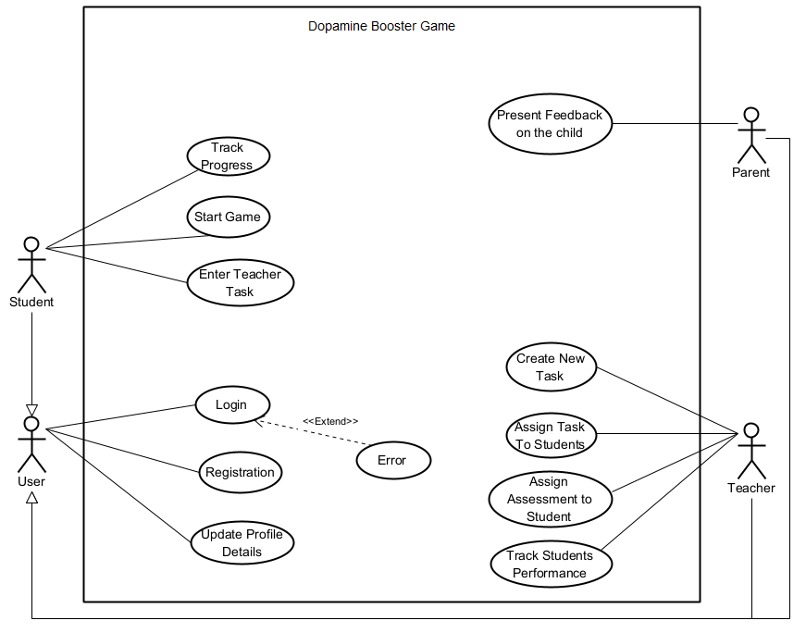

Figure 3: Use-Case Diagram of "Dopamine Booster Game".

*Activity Diagram*

This activity diagram outlines the interaction process between students and teachers within the game, highlighting the balance between educational tasks and gameplay rewards.

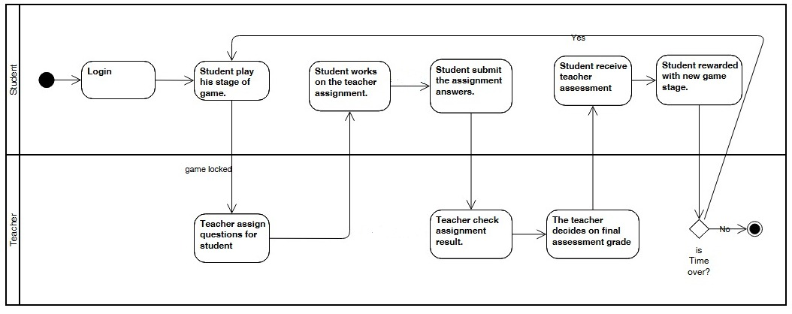

Figure 4: Activity Diagram of "Dopamine Booster Game.

# **5 Tools and Technologies Used**

The selection of tools and technologies for the Dopamine Booster Game was carefully curated to ensure robust data management, efficient real-time processing, and a seamless cross-platform user experience. The software design and architecture play a crucial role in achieving a scalable, secure, and user-friendly application. The system follows a modular approach, breaking down the application into distinct components that interact efficiently, allowing for easier updates, testing, and maintenance. Each technology was chosen for its ability to integrate smoothly within the development ecosystem, ensuring optimal performance, scalability, and maintainability while providing a dynamic and engaging experience for users.

**1. Firebase (Google Cloud Platform)**

Firebase serves as the core backend infrastructure, offering cloud-based services for real-time data handling, secure authentication, and scalable storage.

* **Firebase Realtime Database** – A NoSQL cloud database that synchronizes data in real time across devices. This enables instant updates for game progress tracking, quiz results, and student-teacher interactions without requiring manual refreshes.
* **Firebase Cloud Storage** – A secure file storage solution that manages game assets, user-generated content. It supports seamless media uploads and downloads, ensuring optimized performance.
* **Firebase Authentication** – Provides a secure and scalable authentication system, supporting various login methods, including email/password and Google Sign-In, while handling session management behind the scenes.
* **Firebase App Distribution** – Continuous integration (CI/CD) pipelines tool enables streamlined beta testing and deployment of app updates across platforms, allowing for real-time feedback and iterative improvements.

**2. Flutter & Dart**

Flutter was selected as the primary framework for developing a cross-platform mobile application due to its ability to deliver a native-like experience from a single codebase.

* **Cross-Platform Architecture –** Flutter compiles Dart code into native ARM binaries, utilizing its layered architecture to optimize performance. The framework manages UI rendering with Skia, while the engine, written in C/C++, handles rendering, composition, and system events. The embedder ensures platform-specific integration, including native plugins and threading. This architecture enables smooth animations, high performance on both Android and iOS, and scalability to web and desktop in the future.

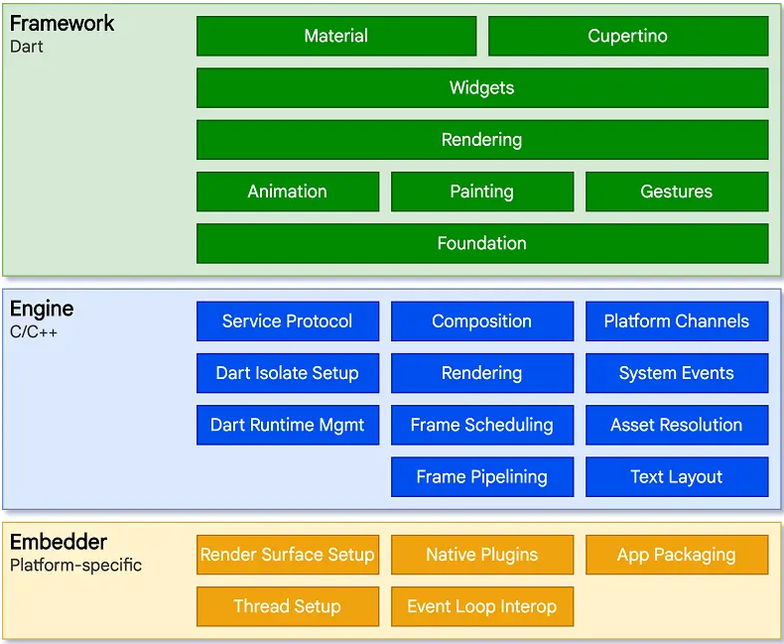

* **State Management with BLoC** – The BLoC (Business Logic Component) library is used to efficiently manage app state by enforcing a unidirectional data flow. This architecture separates UI from business logic, ensuring predictable state transitions and improved maintainability. UI components send **events** to the BLoC, which processes them and interacts asynchronously with the data layer by making requests to repositories or data providers. The response, once received, triggers state updates that are emitted back to the UI. This asynchronous communication ensures smooth performance, prevents UI blocking, and improves scalability.

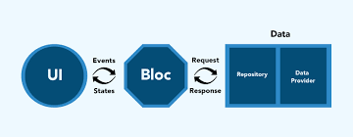

* + **Observer Design Pattern with BlocObserver** – To track and log real-time state changes, the Observer pattern is implemented using a custom BlocObserver. This pattern enables efficient monitoring of BLoC lifecycle events, including creation, state changes, event additions, transitions, errors, and closure. By leveraging BlocObserver,

the application ensures better debugging, maintainability, and responsiveness by logging real-time updates to the business logic layer.

* **Multilingual Support with flutter_localization** – The app fully supports English and Hebrew, with the potential to easily expand to additional languages. The flutter_localization package ensures efficient language management, enabling seamless language switching without performance overhead.
* **Fast UI Rendering** – Flutter’s widget-based declarative UI system allows for highly customized and performant interfaces, ensuring a consistent user experience across devices.
* **Persistent Data Storage with shared_preferences** – The shared_preferences package is used for storing lightweight, key-value-based data on the device. This allows the app to persist user settings, preferences, and authentication states even after the app is closed and reopened. It acts as a simple storage solution for non-sensitive data, ensuring a smoother user experience.

**3. Unity & C#**

The game component of the Dopamine Booster Game is developed using Unity with C#, leveraging powerful 3D rendering and physics-based interactions to create an engaging and immersive experience. Key features include:

* Dynamic 3D game mechanics designed to enhance focus and motivation.
* Sport-based and mindfulness challenges that stimulate dopamine production and improve attention.
* Optimized performance across multiple platforms with Unity’s efficient rendering pipeline.
* Integration with Firebase, enabling real-time progress tracking and cloud-based game data synchronization.
* Utilization of design patterns, specifically the Singleton pattern, to efficiently manage object instantiation. This ensures that elements like rockets for the spaceship and obstacles (asteroids) are consistently generated in the game.

**4. GitHub**

GitHub serves as the version control system, ensuring efficient collaboration and code management across the development team. It provides:

* Branching strategies for feature development, bug fixes, and production releases.
* Issue tracking and project management to streamline development workflows.

These technologies were strategically selected to create a high-performance, scalable, and user-centric application, ensuring smooth operation, real-time data processing, and an engaging user experience. Additionally, the widespread adoption and extensive community support of these tools enable efficient troubleshooting, updates, and future enhancement.

# **6** **Verification and Evaluation**

## **6.1 Evaluation**

### **6.1.1 Overview**

The test plan outlines the procedures and methodologies to evaluate the effectiveness and performance of the "Dopamine Booster Game" in a real-world classroom setting. The primary goal is to determine whether the game improves attention, concentration, and overall academic performance in children with ADHD.

**Objectives**

* Assess the usability and engagement levels of the game.
* Measure improvements in attention and concentration among students.
* Gather feedback from teachers on the game's impact on student behavior and performance.
* Identify any technical issues or bugs in the game.

**Scope**

* The test will be conducted in a real classroom setting with students diagnosed with ADHD.
* The evaluation period will span one week, incorporating regular 10-15 minute gameplay sessions into the school day.
* Feedback will be collected from both teachers and students.

**Constraints and Assumptions**

* **Constraints:**
  + Limited access to classrooms and students for testing purposes.
  + Variations in how different teachers implement the game sessions and engage students.
  + Limited testing time within the school schedule.
* **Assumptions:**
  + Students and teachers will have access to the necessary hardware (e.g., tablets, smartphones).
  + Teachers will integrate the game sessions seamlessly into the daily class routine.
  + Students will follow instructions and engage with the game as intended.

**Test Environment**

* **Hardware:**
  + Tablets or smartphones for each student to play the game.
* **Software:**
  + The latest version of the "Dopamine Booster Game" application.
  + Data analytics tools to monitor and evaluate student performance.
* **Personnel:**
  + A teacher to oversee the class and manage the testing process.
  + A researcher to collect data, provide technical support, and facilitate the evaluation process.

### **6.1.2 Work Plan**

**Phase 1: Preparation**

1. **Permissions and Approvals:**
   * Obtain necessary permissions from school administration and parents for the participation of students.
   * Ensure ethical guidelines and privacy concerns are addressed.
2. **Setup:**
   * Install the "Dopamine Booster Game" application on all required devices.
   * Ensure all devices are functioning properly and connected to the necessary networks.
3. **Training:**
   * Train teachers on how to use the game and monitor student progress.
   * Provide guidelines on how to integrate the game sessions into the daily class schedule.

**Phase 2: Baseline Measurement**

1. **Initial Assessments:**
   * Conduct initial assessments to measure students' current levels of attention, concentration, and academic performance.
   * Utilize standardized tests or teacher observations to establish a baseline for comparison.
2. **Data Collection:**
   * Record baseline data to serve as a reference point for evaluating improvements.

**Phase 3: Implementation**

1. **Gameplay Sessions:**
   * Incorporate 10-15 minute game sessions into the daily school schedule for one week.
   * Ensure that each student plays the game for the designated time each day.
2. **Monitoring:**
   * Monitor student engagement and participation during game sessions.
   * Ensure technical issues are promptly addressed to minimize disruptions.

**Phase 4: Mid-Test Evaluation**

1. **Preliminary Feedback:**
   * Conduct a mid-test evaluation to gather preliminary feedback from teachers and students.
   * Observe student engagement and any immediate behavioral changes.
2. **Adjustments:**
   * Make any necessary adjustments to the testing process based on preliminary feedback.

**Phase 5: Final Assessment**

1. **Post-Test Assessments:**
   * At the end of the one-week period, conduct final assessments to measure any improvements in attention, concentration, and academic performance.
   * Utilize the same standardized tests or observational methods as the baseline measurement for consistency.
2. **Data Collection:**
   * Record post-test data to compare with baseline measurements.

**Phase 6: Feedback Collection**

1. **Teacher Feedback:**
   * Conduct interviews or surveys with teachers to gather detailed feedback on the game's impact on student behavior and performance.
   * Ask teachers to provide specific examples and observations.
2. **Student Feedback:**
   * Collect feedback from students about their experience with the game.
   * Use age-appropriate methods such as surveys or informal discussions to gather their insights.

### **6.1.3 Final Evaluation Stage**

* **Quantitative Data:**
  + Pre and post-test scores on attention and concentration assessments.
  + Game usage statistics (e.g., time spent playing, levels completed).
* **Qualitative Data:**
  + Teacher feedback on student behavior and performance.
  + Student feedback on game enjoyment and engagement.

**Analysis Methods:**

* **Comparative Analysis:**
  + Compare pre and post-test scores to determine improvements in attention and concentration.
  + Analyze changes in academic performance metrics.
  + An opinion from the teacher as to whether an improvement was made.
* **Usage Analysis:**
  + Evaluate game usage statistics to identify patterns in engagement and usage frequency.

### **6.1.4 Reporting**

1. **Report Compilation:**
   * Compile a comprehensive report detailing the test findings.
   * Include both quantitative and qualitative data analyses.
2. **Key Sections:**
   * **Introduction:**
     + Overview of the test plan and objectives.
   * **Methodology:**
     + Detailed description of the testing procedures and environment.
   * **Results:**
     + Presentation of quantitative improvements in attention, concentration, and academic performance.
     + Summary of qualitative feedback from teachers and students.
   * **Discussion:**
     + Analysis of the findings and their implications.
     + Identification of any technical issues or areas for improvement.
   * **Conclusion:**
     + Summary of key insights and recommendations for future development.

By following this comprehensive test plan, we aim to rigorously evaluate the "Dopamine Booster Game" in a real-world educational setting. This will ensure that the game is both effective and user-friendly, ultimately providing a valuable tool for children with ADHD to manage their symptoms through engaging and interactive gameplay.

## **6.2 Verification**

The testing for the 'Dopamine Booster Game' will be conducted iteratively across the following areas: Mobile Application – Data Analysis – Game Mechanics. We will employ unit tests, functional tests, and manual QA for user experience testing.

The Unity Test Framework will be used for the Mobile Application and Game Mechanics, while the data processing will be tested with accuracy matrices and mock data. The goal is to ensure proper functionality, user satisfaction, and reliable data output.

|  |  |  |  |
| --- | --- | --- | --- |
| **Test** | **Module** | **Tested Function** | **Expected Result** |
| 1 | Mobile Application | Game Loading | Fast game load time < 2s |
| 2 | Mobile Application | Steady framerate | Minimum of 30 fps maintained |
| 3 | Mobile Application | UI/UX | Intuitive and user-friendly interface |
| 4 | Mobile Application | Device Compatibility | Supports all mobile devices (Android, iOS) |
| 5 | Mobile Application | Transition Between Screens | Smooth transitions < 2s |
| 6 | Mobile Application | Feedback Adaptability | The game stage adjusts based on the teacher assessment grade. |
| 7 | Mobile Application | Reward System | Rewards triggered by achieving points milestones |
| 8 | Game Mechanics | Response to Inputs | Accurate and quick response to user inputs |
| 9 | Game Mechanics | Authentication System | User can log in with valid credentials (student, parent, teacher) |
| 10 | Game Mechanics | Physical Activity Integration | Device notification displayed |
| 11 | Game Mechanics | Limiting Screen Time | Game enforces screen time limits, based on settings |
| 12 | Data Analysis | Accurate Logging of User Performance | Performance data (tasks completed, response times) correctly logged |
| 13 | Data Analysis | Data Sync with Database | Data syncs correctly with database storage for analysis |

# **7** **Challenges and Solutions**

## **7.1 Technical and Engineering Challenges**

Throughout the development process, we faced several challenges that required innovative solutions. These challenges mainly spanned UI responsiveness, game integration, data management, and language localization.

**7.1.1 UI Responsiveness and Cross-Platform Adaptability**

**Challenge:** Ensuring a consistent and responsive user interface across various devices, including smartphones and tablets with different screen sizes and resolutions.

**Solution:** We utilized Flutter’s ScreenUtil package and Unity’s responsive UI tools to dynamically adjust UI elements based on the screen dimensions. This ensured that all interface components were properly scaled while maintaining usability and aesthetics.

**7.1.2 Animation Handling for Spaceship Previews**

**Challenge:** Spaceship preview animations, crucial for the game’s visual appeal, required smooth movement and transitions while remaining within designated UI boundaries.

**Solution:** We implemented real-time boundary checks to ensure that objects did not drift off-screen and used randomized movement vectors to create dynamic yet controlled motion patterns.

**7.1.3 Language Localization (Hebrew & English)**

**Challenge:** Supporting Hebrew as a right-to-left (RTL) language required UI adjustments to maintain proper text alignment and layout consistency.

**Solution:** We used flutter_localization to dynamically switch between English and Hebrew. Additionally, RTL-aware UI components were customized to ensure mirrored text alignment and proper positioning of navigation elements when switching to Hebrew.

**7.1.4 Unity and Flutter Integration Issues**

**Challenge:** Combining Unity (for the game) and Flutter (for the main app) presented technical hurdles. Initially, we attempted to use the [flutter_unity_widget (v2022.2.1)](https://pub.dev/packages/flutter_unity_widget/versions) to embed the Unity game within Flutter. However, this integration failed due to compatibility issues.

**Solution**: Instead of embedding Unity within Flutter, we hosted the Unity game as a separate APK on Firebase Storage. The app dynamically downloads the game for student users.

* Advantages: Reduces the app’s memory footprint and allows us to keep the main app lightweight
* Disadvantages: No real-time communication between Flutter and Unity (which the widget would have provided), requiring workarounds for progress tracking.

## **7.2 Personal Challenges and Time Constraints**

Beyond technical issues, the project posed significant time management challenges, especially for a two-person team developing a large-scale application.

**7.2.1 Learning New Technologies**

**Challenge:** Before starting development, we had to learn Flutter, Unity, C#, Firebase, and Bloc state management, which was time-consuming since we had no previous knowledge or experience in the main technologies we decided to work with.

**Solution:** We dedicated the early stages of development to self-learning and rapid prototyping, allowing us to gain proficiency before full implementation and a better understanding of the work division we will have through the project.

**7.2.2 Balancing Development Time**

**Challenge:** The project required handling game mechanics, UI design, backend and frontend development, and testing simultaneously with a limited timeframe.

**Solution:** We adopted an agile workflow, prioritizing core functionalities first, then iterating based on testing and feedback to avoid scope creep and to decide about requirements changes based on priority.

**7.2.3 Working with Limited Resources**

**Challenge**: Unlike large teams with dedicated designers, backend engineers, and QA testers, we had to divide responsibilities efficiently while ensuring high-quality development. Additionally, we faced hardware limitations, particularly the lack of an Apple device, which made it difficult to properly test and debug the iOS version of the app.  
**Solution:** We streamlined our workflow by leveraging open-source libraries and focusing on automation where possible (e.g., Firebase for backend tasks and pre-built localization tools). For iOS testing, we relied on Flutter’s iOS and Android emulator and external testers with Apple devices to validate functionality, though this added extra iteration cycles compared to having direct access to physical hardware.

## **7.3 Consideration in Decision-Making**

Throughout the development of the Dopamine Booster Game, the decision-making process was driven by a set of guiding principles aimed at balancing functionality, UI/UX, and available resources. Each decision was carefully considered in terms of its technical feasibility, impact on user engagement, and the constraints imposed by time and resources.

Technical feasibility was a major factor in shaping our decisions, as we had to ensure that solutions would be compatible across both Android and iOS platforms, while also

maintaining scalability and performance. User-centered design was another core consideration, with the goal of ensuring an engaging and intuitive experience for students, teachers, and parents. Every feature and design change were evaluated based on its ability to meet the needs of these diverse user groups.

Resource management played a significant role in our decision-making, especially given the small development team and limited access to specific hardware, such as Apple devices. To maximize efficiency, we leveraged open-source libraries and focused on automating backend tasks wherever possible. Despite these constraints, we prioritized key functionalities to ensure the app’s core features were developed first, which meant deferring certain aspects, such as the parent UI and related functions, to later stages of the project and we were unable to fully complete it in time.

Lastly, the team regularly reassessed decisions to adapt to the evolving needs of the project. As challenges arose, we remained flexible, ensuring the game stayed stable, functional, and scalable while also meeting the expectations of the target audience.

# **8 Results and Conclusion**

## **8.1 Achieving the Project Goals**

The Dopamine Booster Game successfully met its core objectives of providing an engaging and structured approach to helping children with ADHD improve focus, attention, and behavioral patterns through gamification in everyday life during school time and through collaboration with teachers. The app integrates neuroscientific principles, interactive challenges, and adaptive gameplay to maintain engagement while reinforcing positive habits.

**Key achievements include:**

* **Cross-platform functionality:** The game runs smoothly on both Android and iOS devices, ensuring accessibility for a broad user base.
* **Game Development:** 3D Game with Sport-based challenges and mindfulness practices to boost focus, motivation, and dopamine, balancing activity and gameplay limits.
* **Secure Authentication System:** A robust login, logout, and signup process was implemented using Firebase Authentication, ensuring secure user access with support for email/password authentication. Role-based access controls.
* **Optimized UI/UX Experience:** The app was designed with clear navigation, intuitive controls, and a visually appealing interface to ensure a smooth and engaging user experience.
* **Localization Support**: With flutter_localization, the game supports multiple languages, ensuring a broader reach and inclusivity.
* **Data-Driven Insights:** Performance tracking and analytics allow teachers to monitor progress and adjust strategies accordingly.

The project met its success criteria, delivering a well-optimized, engaging, and scientifically grounded application that aligns with its intended purpose.

## **8.2 Reflections on our Development Process**

The development of the Dopamine Booster Game was a challenging yet rewarding experience. Working on a project of this scale required effective time management, rapid learning, and adaptability to overcome unexpected obstacles.

**Learning New Technologies**

At the start of development, we had to learn new frameworks and programming languages, including Flutter, Unity, C# Firebase, and BLoC for state management and many more. The initial learning curve was steep, but as the project progressed, our understanding deepened, allowing us to implement complex features efficiently and a clearer division of work between us that is adapted to each of our strengths.

**Managing a Large-Scale Project**

Developing an app with multiple interactive components, a real-time database, and cross-platform support required careful planning. Dividing tasks, setting clear milestones, and maintaining version control were essential to keeping the project on track. Despite tight schedules, we managed to deliver a well-rounded and fully functional application.

**Balancing Development with Academic Responsibilities**

With a small team of two developers working on this project alongside university coursework or job, time management was a significant challenge. Allocating dedicated hours for development, debugging, and testing required strict prioritization of tasks to ensure steady progress.

**Adapting to Changing Requirements**

During development, several features required modification based on feasibility and testing feedback. This iterative approach allowed us to refine our design and implementation, ultimately resulting in a more polished product.

**Learning lessons**

Our approach to testing and evaluation was effective in assessing the app’s impact on engagement and performance. By involving children from our personal networks and gathering structured feedback from teachers, we ensured practical insights into real-world usage. In retrospect, a more diverse participant pool and extended testing duration could have strengthened our findings. While we met key benchmarks, such as improved engagement and quiz scores, limitations in resources and time prevented full implementation of the parent UI and role-based features. Given more time, we would refine the game mechanics further and enhance data analytics for deeper behavioral insights. Overall, our structured methodology validated the app’s effectiveness while highlighting areas for future development.

# **9 User Guide Documentation**

Welcome to the “Dopamine Booster Game” User Guide.

The “Dopamine Booster Game” is a cross-platform flutter-based mobile application designed to help manage ADHD symptoms in an engaging and accessible way. Built on neuroscientific research and innovative game mechanics, it stimulates dopamine production through interactive activities that enhance attention and cognitive function. The app provides a scalable, cost-effective intervention suitable for diverse populations, fostering a fun and motivational learning experience while supporting student-teacher collaboration in daily school life.

This documentation will guide you through the features and functionalities of “Dopamine Booster Game”, offering step-by-step instructions to help you make the most of the system.

Please note that this documentation is divided into two main sections: The first section [9.1] is intended for the general use of the application from overall view and specific user roles such as teacher or student. The second section [9.2] is specifically designed for the game itself which is available for the use of student users only.

## **9.1 Dopamine Booster – Application**

**Login Page:**

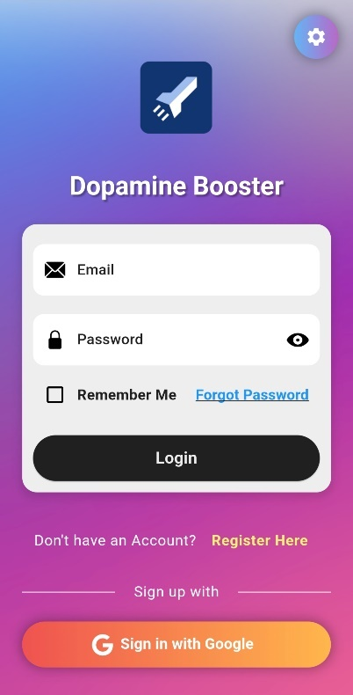

The login page allows users to securely access their accounts. Enter your email address and password in the respective fields and tap the "Login" button. If you forget your password, click "Forgot Password?" to receive reset instructions, Optionally, log in using external options (e.g., Google).

**Key Features**

1. **Remember Me**: Automatically saves your email for future logins by checking this box or removes a previously saved email based on the checkbox state.
2. **Forgot Password**:

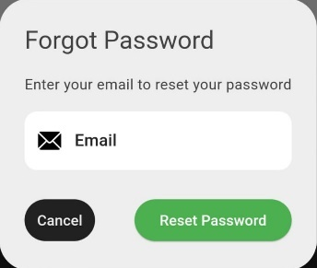

Reset your password by entering your email in a dialog box and following the emailed instructions.

1. **Login Button**: Authenticate your credentials and proceed to the app.
2. **Error Handling**: Displays messages for incorrect credentials or connectivity issues.

**Sign-Up Page:**

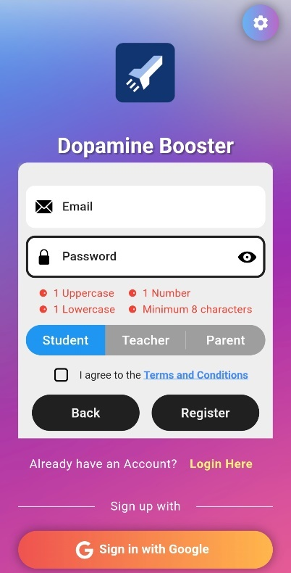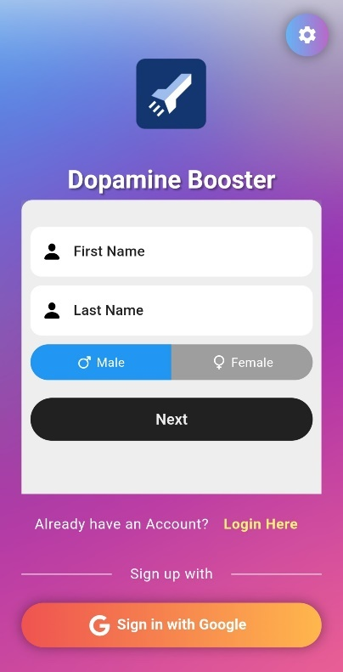

New users can create an account on the sign-up page. Fill in your name, provide a valid email, create a strong password, and select your role (Teacher or Student or Parent). Tap "Register" to complete the process. Ensure you agree to the terms and conditions before proceeding.

**Key Features**

**Step 1: User Information**

1. **Name Field**:
   * The name must be no longer than 30 characters.
2. **Gender Selection**:
   * A toggle is provided to choose between "Male" (default) and "Female" genders.
3. **Next Button**:
   * Moves to Step 2 of the registration process after validating Step 1 inputs.

**Step 2: Account Information**

1. **Email Field**:
   * The app validates the format to ensure it is correct (e.g., example@domain.com).
2. **Password Field**:
   * Password requirements are:
     + At least one uppercase letter.
     + At least one lowercase letter.
     + At least one number.
     + A minimum of 8 characters.
   * A visibility toggle icon allows users to show or hide the password.
3. **Password Rules Indicators**:
   * Displays real-time feedback as users input their password, showing which rules are met.
4. **User Role Toggle**:
   * Select the desired user role:
     + **Student** (default).
     + **Teacher.**
     + **Parent.**
5. **Terms and Conditions**

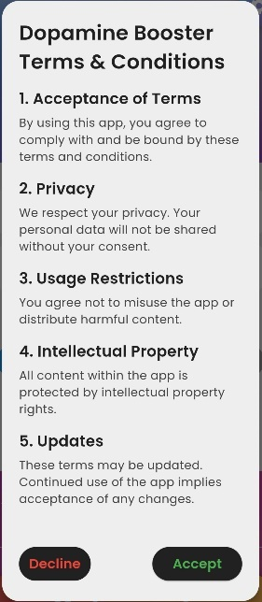

* + Users must agree to the app's terms and conditions checkbox to proceed.
  + Tapping the linked text opens a dialog with detailed terms and conditions. Users can scroll through the sections and either accept or decline.

1. **Back Button**:
   * Allows users to return to Step 1 if needed.
2. **Register Button**:
   * Submits the form if all fields are valid and the terms are accepted.
   * Displays a progress indicator while processing.

**Feedback Messages**

1. **Success**: Displays "Sign in successful" upon successful registration.
2. **Failure**: Displays "Invalid email or password" for invalid inputs.
3. **Incomplete Form**: Alerts users to fill all fields and accept the terms if required fields are not completed.

**Settings page:**

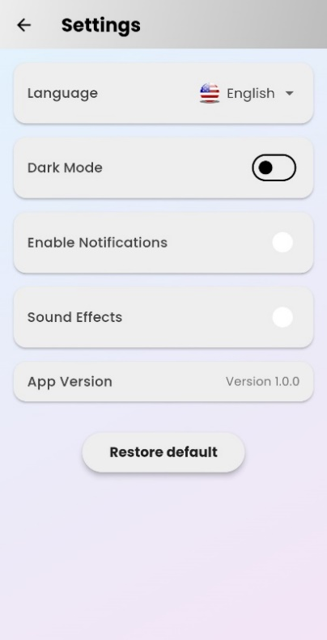

Change the app language (e.g., English or Hebrew), Enable or disable notifications and sounds, app version information and reset to default settings button

**Key Features**

**1. Language Selection**

Enables users to change the app's language dynamically.

* **UI Element**: A dropdown menu for selecting available languages.
  + Displays flags and names of the languages.
* **Supported Languages**: English (default) and Hebrew.

**2. Dark Mode Toggle**

Allows users to switch between light and dark themes.

**3. Notifications Toggle**

Let’s users enable or disable app notifications.

**4. Sound Effects Toggle**

Allows users to turn app sound effects on or off.

**5. App Version Display**

Displays the current app version to the user.

**6. Reset to Default Settings**

Restores all settings to their default values

**Student Dashboard:**

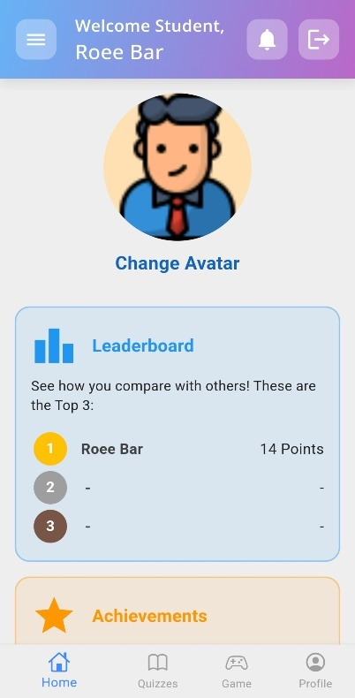

After logging in, users land on their dashboard, which provides quick access to all features. The student dashboard is designed to motivate and guide students as they engage with learning activities and track their progress.

**Key Features**

**1. Changing Your Avatar**

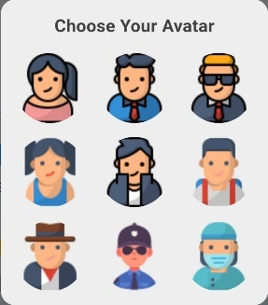

1. On the Home Screen, tap the Avatar displayed at the center.
2. A dialog will appear showing various avatar options.
3. Select an avatar by tapping on it.
4. The selected avatar will update immediately, and the dialog will close.

**Notes:**

* The default avatar is selected based on the user’s gender.

**2. Viewing the Leaderboar**

1. Scroll down to the Leaderboard section.
2. The leaderboard displays the top users with their:
   * Position
   * Username
   * Total score

**Top Application Bar:**

The Main App Bar provides essential navigation and user (from all roles) interaction options within the Dopamine Booster Game app.

**Key Features**

1. **Personalized Welcome Message:** Displays a localized greeting along with the user’s role (Student, Teacher, or Parent) and full name when logged in.
2. **Notifications Icon:**

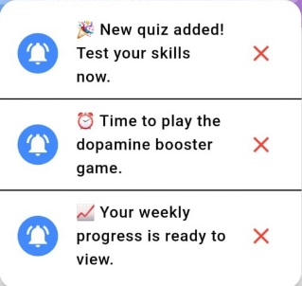

Shows recent updates and alerts for the user.

1. **Logout Button:**

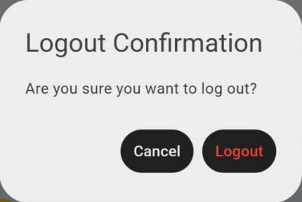

Allows users to securely log out after confirmation.

1. **Navigation Menu Button:**

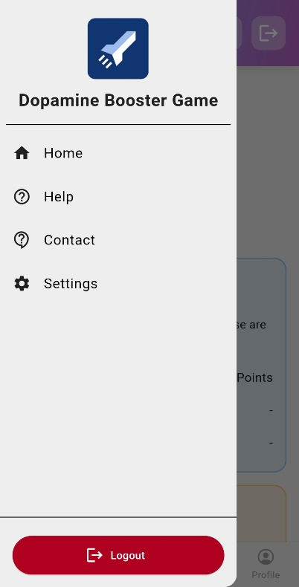

Opens the side drawer for quick access to different app sections.

**Bottom Navigation Bar:**

* **Home:** Displays the latest updates, notifications, and motivational content to inspire learning.
* **Quizzes:** Allows students to select quizzes by grade and category, promoting knowledge retention.
* **Game:** Gamified activities aimed at boosting focus and managing ADHD symptoms.
* **Profile:** Students can view and update their profile details.

**Contact Page:**

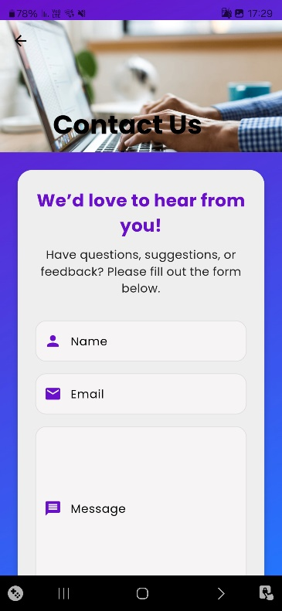

The Contact Screen allows users to send feedback to the Dopamine Booster App team via email. This form collects the user's name, email address, and message, then sends the details to a dedicated developer email address.

**Key Features**

**Form Fields:** The user is asked to fill in their Name, Email, and Message. Each field includes validation to ensure correct input.

**Email Sending:** After submitting the form, an email is generated with the user's details, and it is sent to: dopamineboosterapp@gmail.com.

**Error Handling:** If there is an issue with the email client, an error message will be displayed.

**Help Page:**

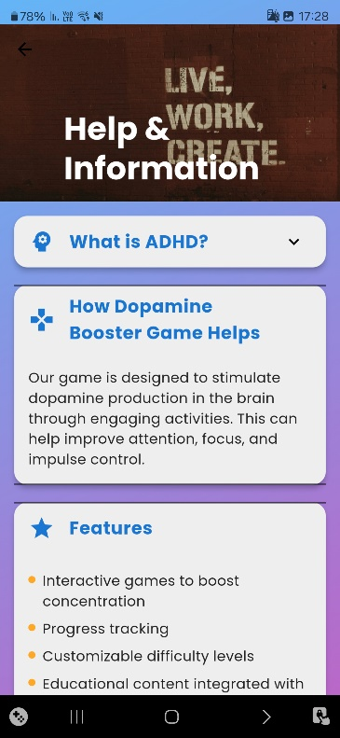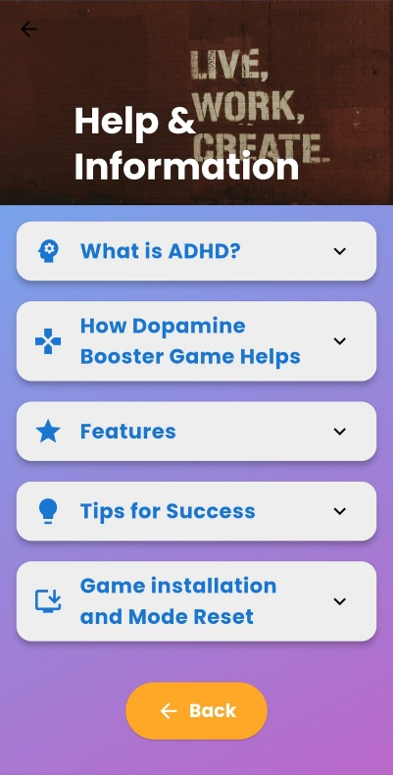

The Help Screen provides users with essential information about the Dopamine Booster App, its features, ADHD, tips for success, and installation help. It also includes a reset button to address any installation-related issues.

**Key Features**

* Sections: The screen is divided into multiple sections:
  + ADHD Description: Provides basic information about ADHD.
  + Dopamine Game Description: Explains the purpose and goals of the Dopamine Booster game.
  + Game Features: Lists key features of the app.
  + Tips for Success: Offers helpful advice to improve the gaming experience.
  + Game Installation Help: Guides the user on how to install the app and includes a button to reset the installation status in case re-installation needed by the student user.
* Expandable Content: Each section is collapsible and can be expanded to view more details, making the interface clean and organized.
* Reset Installation Button: In the "Game Installation Help" section, a reset button allows users to reset the installation status and displays a success message after the reset.
* Navigation: At the bottom, a Back button allows users to return to the previous screen

**Grade Selection Page:**

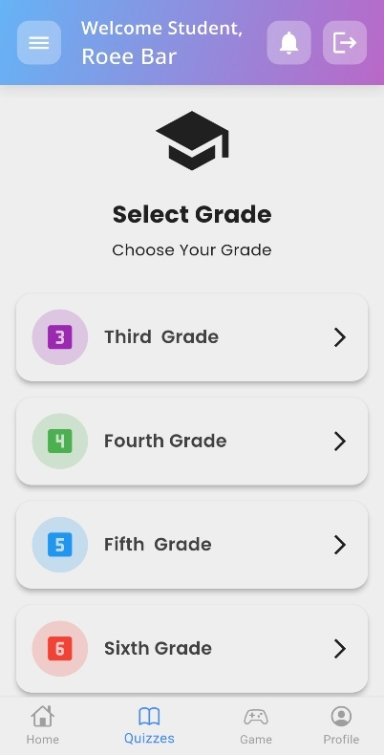

The Grade Selection Screen is an intuitive interface designed to help users select their educational grade. It guides them to relevant content categories and quizzes tailored to the user’s specific academic needs based on their chosen grade level. Below is a detailed guide to the screen's features and functionalities.

**Key Features**

1. **Animated Header**

* Displays a prominent school icon and motivational text encouraging the user to select their grade.

2. **Scrollable Grade List**

* A vertically scrollable list of available grade levels.
* Each grade option includes:
  + Grade Name: Displayed in bold text.
  + Icon: A visual representation for each grade, such as numbers or thematic icons.
  + Color-coded Background: A subtle background color differentiates each grade visually.

**Categories Screen**

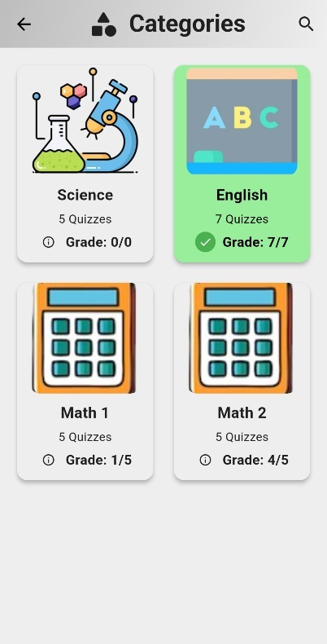

The Categories Screen displays a list of quiz categories customized for the selected grade.

**Key Features**

* **Search Functionality:**
  + Use the search bar to find categories based on keywords.
* **Quiz Categories:**
  + Categories include topics like Sports, Science, History, Math, and more.
  + Each category card shows the number of quizzes available.
* **Category Status:**
  + Completed categories are highlighted in green with a checkmark.
  + Incomplete categories show an info icon with the current score.

**Steps**

1. **Explore Categories:**
   * Scroll through the grid to view available categories.
   * Tap on a category card to start its quizzes.
2. **Start a Quiz:**
   * After tapping a category, you'll be redirected to the Quiz Screen for that category
3. **Track Progress:**
   * Completed quizzes and their scores are visually displayed on category cards.

**4. Category Tiles**

Each category is displayed as an interactive tile containing:

* **Category Image:** Displays a unique or default image for the category.
* **Category Name:** Localized name of the category.
* **Quiz Count:** Number of available quizzes in the category.
* **Status Icon:** Indicates completion status with score details.

**Quizzes Page:**

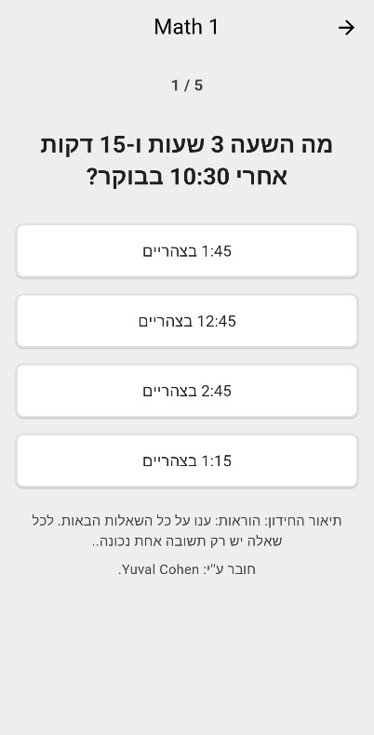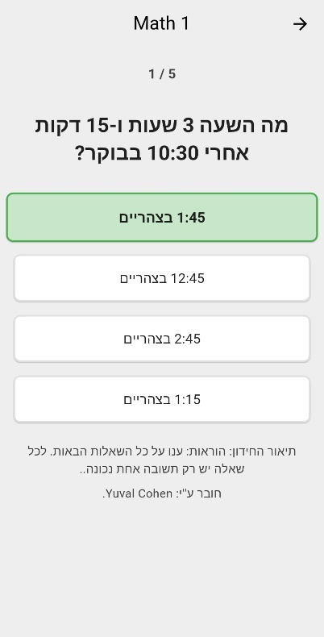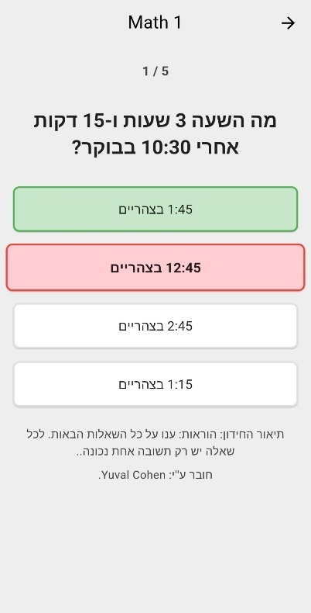

The Quizzespage displays a quiz interface for the Dopamine Booster Game app. This section outlines its key components and instructions for use.

**Key Features**

1. **Category-based Quiz Selection:**
   * The widget allows users to take quizzes based on a selected category, provided via the category parameter.
   * Displays quizzes with a progress indicator showing the user's progress.
2. **Quiz Interaction**
   * Users can select answers for each question. Once an answer is selected, the screen evaluates whether it's correct.
   * After answering, the widget displays an animation to indicate selection, followed by a brief delay before progressing to the next question or showing results.
3. **Score Tracking:**
   * The score is updated dynamically as the user answers questions. The final score is displayed after completing all questions.
4. **Timer Check:**
   * The widget uses a timer to ensure the user plays the quiz within a certain time window. If the time expires, the user will not be able to play again until the timer resets.
5. **Results Dialog:**

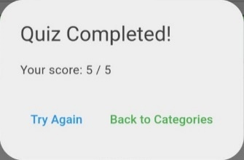

* + After completing the quiz, a results dialog appears showing the user's score and options to retry ("Try Again" button to reset the quiz) or "Back to Categories" button to exit the quiz returning to categories page and save progress. The user's score is saved to the database upon completion.

1. **Localization Support:**
   * The app supports both RTL (Right-to-Left) and LTR (Left-to-Right) languages, dynamically adjusting text direction and content as per the selected locale.

**Game Page:**

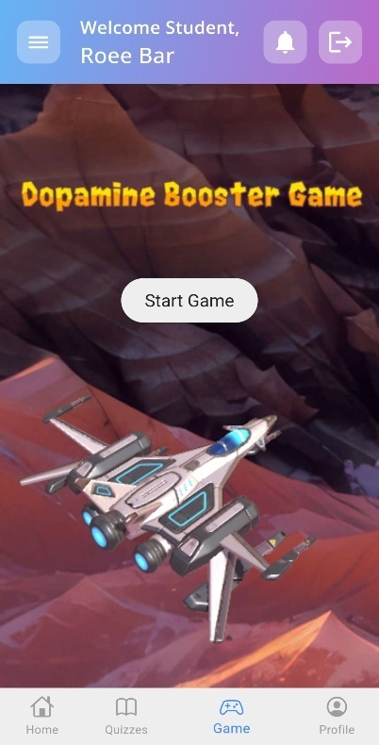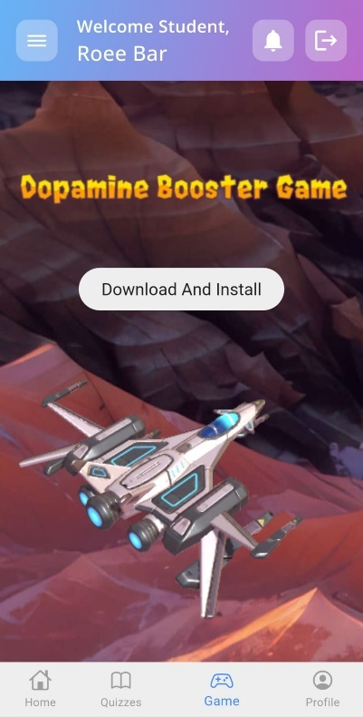

The Game Page serves as the central hub for downloading, installing, and launching the Dopamine Booster Game. It includes a built-in timer to regulate gameplay, providing users with a cooldown period between sessions to encourage healthy usage.

**Key Features**

1. **Download and Install**:
   * If the Dopamine Booster Game is not installed on your device, the app provides a **Download & Install** button to retrieve the APK file.
   * Once downloaded, the APK file will be automatically opened for installation. Follow on-screen instructions to complete the process.
2. **Start Game**:
   * After installation, the **Start Game** button becomes visible, allowing you to launch the Dopamine Booster Game directly from the app.
3. **Cooldown Timer**:
   * After starting the game, a **1-hour cooldown timer** is activated.
   * During this cooldown, the Start Game button is locked, and a countdown is displayed in the format **HH:MM:SS**.
   * Once the cooldown period ends, the Start Game button is re-enabled.
4. **Installing the Game**:
   * During installation, grant any required permissions to allow the app to install external files. Once installed, the game will be ready to launch

**Profile Page:**

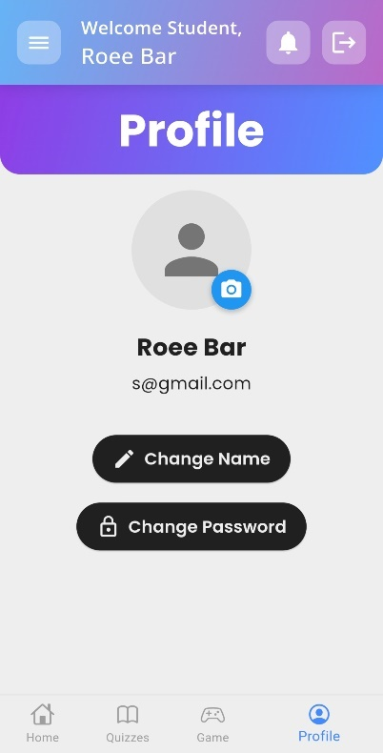

The **Profile Screen** allows users to view and edit their profile details, including updating their name and changing their password. This page is shared for all user types.

1. **User Avatar**: Displays a circular avatar with a default icon, which can be changed.
2. **User Information**: Shows the current username and email.
3. **Change Name**:

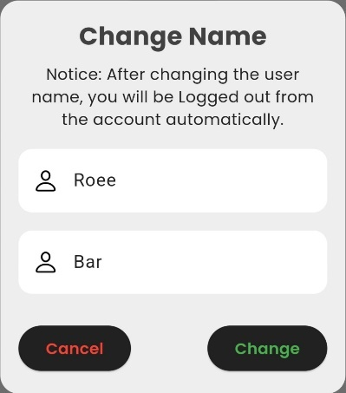

Users can modify their first and last names through a dialog, their saved first and last name already entered and ready to be modify. **Notice:** after changing the username the app will be logged out from the account automatically.

1. **Change Password**:

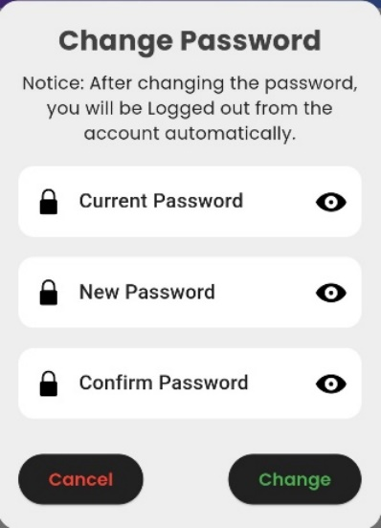

Users can change their password by entering their current password and a new one. Password visibility can be toggled. **Notice:** after changing the password the app will be logged out from the account automatically.

**Teacher Dashboard:**

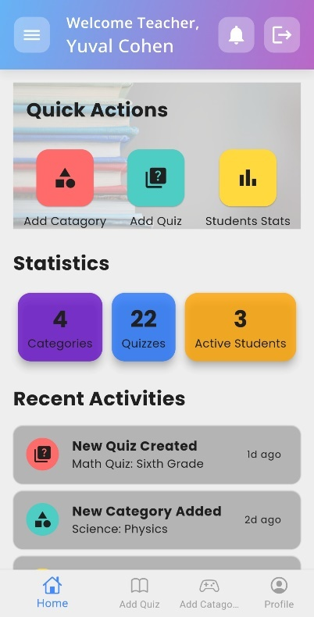

The teacher home screen is the central dashboard for teachers, providing quick actions, statistics, and recent activities related to quizzes, categories, and students. Teachers can manage categories, quizzes, and track student progress with easy navigation options.

**Key** **Features**

1. Quick Actions:
   * Add Category: Create new quiz categories
   * Add Quiz: Add new quizzes.
   * View Stats: View detailed student progress and statistics.
2. Statistics: Displays live counts of:
   * Categories: Total number of quiz categories.
   * Quizzes: Total number of quizzes available.
   * Active Students: Total number of students.
3. Recent Activities: A feed of recent actions, such as quiz creation, category addition, or new student joins, presented with icons, titles, and time.

**Navigation**

* Add Category and Add Quiz buttons take users to the respective screens for managing categories and quizzes.
* View Stats navigates to the Teacher Stats Page, providing detailed student statistics.

**Bottom Navigation Bar:**

* **Home:** Shows an overview of student activity, key notifications, and analytics.
* **Add Quiz:** Teachers can create, edit, and assign quizzes to specific grades or students.
* **Add Category:** View detailed progress reports for individual students or the class.
* **Profile:** Update account information or access settings related to teaching tools.

**Teacher Stats Page:**

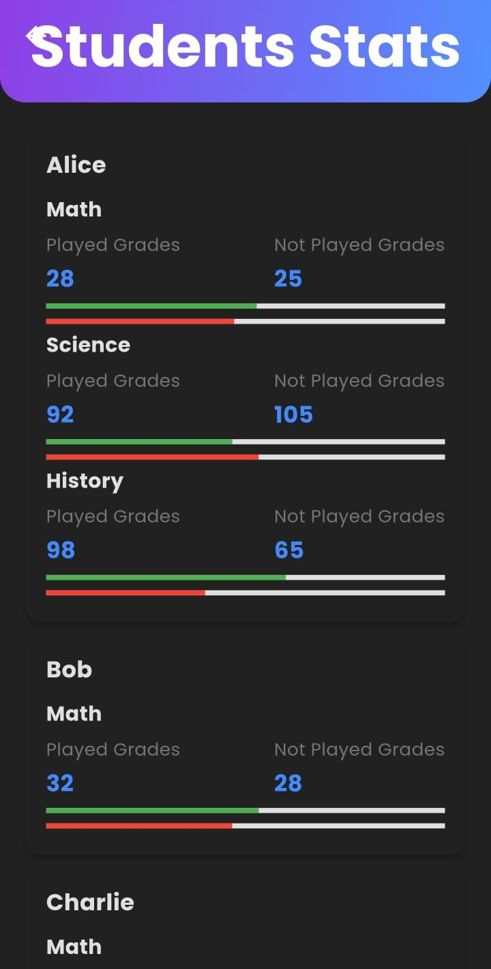

The Teacher Stats Page is a part of the teacher's dashboard. Upon accessing this screen, the data is fetched automatically, displaying detailed breakdown of student progress for different categories of quizzes (e.g., Math, Science). It fetches data from the database and calculates the total scores for each category based on whether the quizzes have been played or not, allowing them to assess where students might need improvement and if or how much the Dopamine Booster Game assist in improving academic performance.

1. **Student Progress Display:**
   * Each student’s data is displayed in a card.
   * Shows the student’s name and their grades in various categories.
2. **Category Stats:**
   * For each category, it displays the total score for both played and not played quizzes grade in each of the category the student tested. The meaning of “Played or Not Played Grades” lay in the app tracking of the student timing of when he took the quizzes and got the results – before or after playing our 3D game.
   * A progress bar shows the comparison of played vs. not played scores.
3. **Dynamic Data Loading:**
   * Data is fetched asynchronously from the Firebase database.
   * The screen updates automatically with new data.

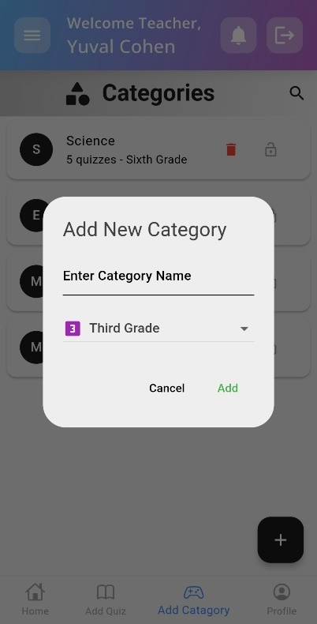**Add Category Page:**

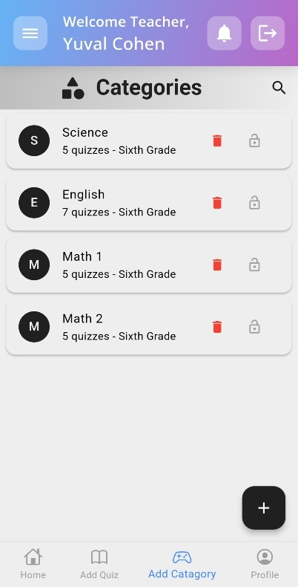

The Add Categories Screen allows teachers to manage categories of quizzes in the Dopamine Booster app, including adding, deleting, and locking/unlocking categories. Below are the operating instructions for using the features available on this screen:

**1. Viewing Categories**

* Upon opening the screen, all categories are displayed in a list.
* Each category includes the name, the associated grade, and the number of quizzes included.

**2. Adding a New Category**

* To add a new category, tap the floating action button with the "Add" icon.
* A dialog will prompt you to enter the category name and select the grade level (e.g., Third Grade, Fourth Grade).
* After filling in the details, click the **Add** button to create the new category.
* The new category will be added to the list, and the UI will refresh to reflect the changes.

**3. Deleting a Category**

* To delete a category, tap the red trash can icon next to the category in the list.
* A confirmation dialog will appear asking for confirmation before deleting the category
* If confirmed, the category will be removed from the list, and the UI will update accordingly.

**4. Locking/Unlocking a Category**

* Each category can be locked or unlocked by clicking the lock icon in the list.
* A **locked** category is denoted by a closed lock icon, and an **unlocked** category is denoted by an open lock icon.
* Tapping the lock icon toggles the lock state, and the change will be reflected in the app's database and will lock the selected category from being added more quizzes.

**5. Search Functionality**

* Categories can be filtered using the search bar at the top of the screen allows users to quickly filter categories based on the category name from the presented list.

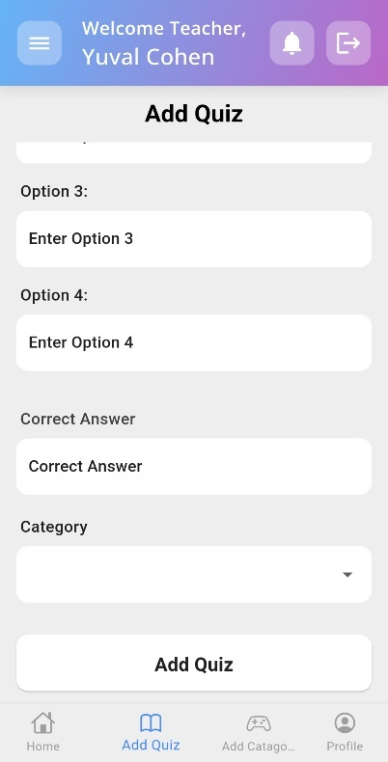**Add Quiz Page:**

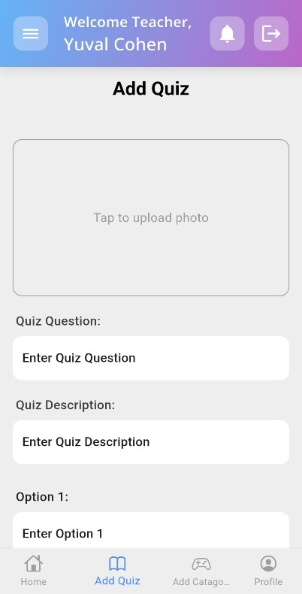

The Add Quiz Page is a page that allows an author (Teacher Role) to create and submit a new quiz into a selected category. The quiz includes a question, four answer options, a correct answer, a description, an associated category, and an optional image picked from the user phone gallery.

**Key Features**

1. **Category Selection**: Users can select an open category for the quiz from a dropdown list that contains all the unlocked categories
2. **Image Upload (Optional)**: Users can upload an image to accompany the quiz by tapping on the image section and picked existing photo from his phone gallery.
3. **Text Inputs**: Fields for entering the quiz question, description, provide four answer options, and specify correct answer (by entering one of the options as the correct choice).
4. **Form Validation**: The form ensures that all fields are properly filled and that the correct answer matches one of the provided options.
5. **Submission**: Tap the **Add Quiz** button. Once validated, the quiz is submitted, and the information is saved to Firebase. A success or error message is displayed based on the submission outcome, the form will reset for a new quiz entry.

## **9.2 Dopamine Booster – Game**

In this section we will describe the “Dopamine Booster Game” screens and features available for the student user only.

**Main Menu:**

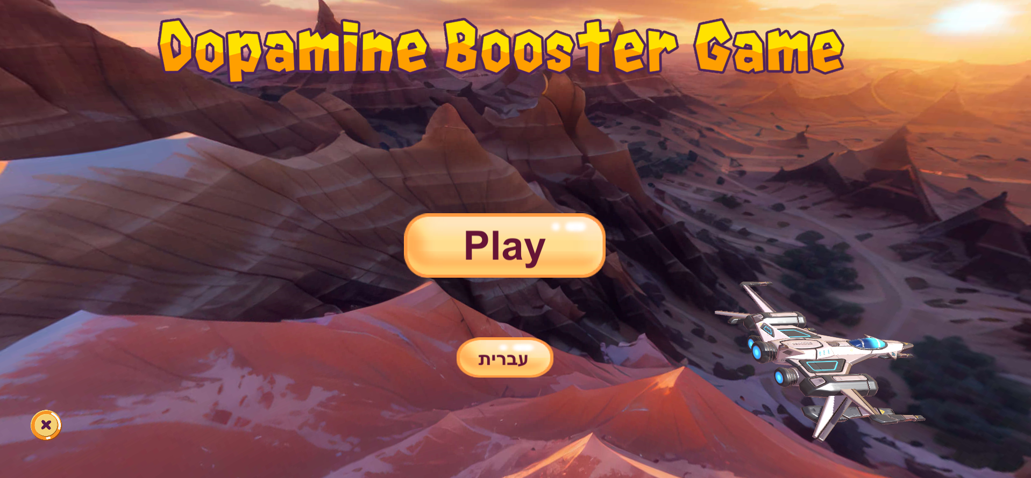

**Main Screen Description**:  
The primary screen of the game serves as the main entry point for users. At the center of the screen, the game's title is prominently displayed in bold and visually appealing typography. Below the title, two distinct interactive buttons are presented:

1. **Language Toggle Button (Label: "Hebrew")**:  
   Located in a clearly visible area, this button allows users to switch the interface language to Hebrew seamlessly, ensuring accessibility for Hebrew-speaking players.
2. **Play Button**:  
   Positioned centrally for easy access, this button transitions the user to the next

screen. The following screen includes a detailed explanation of the gameplay mechanics and initiates the game experience.

The design emphasizes user-friendliness, with intuitive navigation and a polished aesthetic that invites players to engage further.

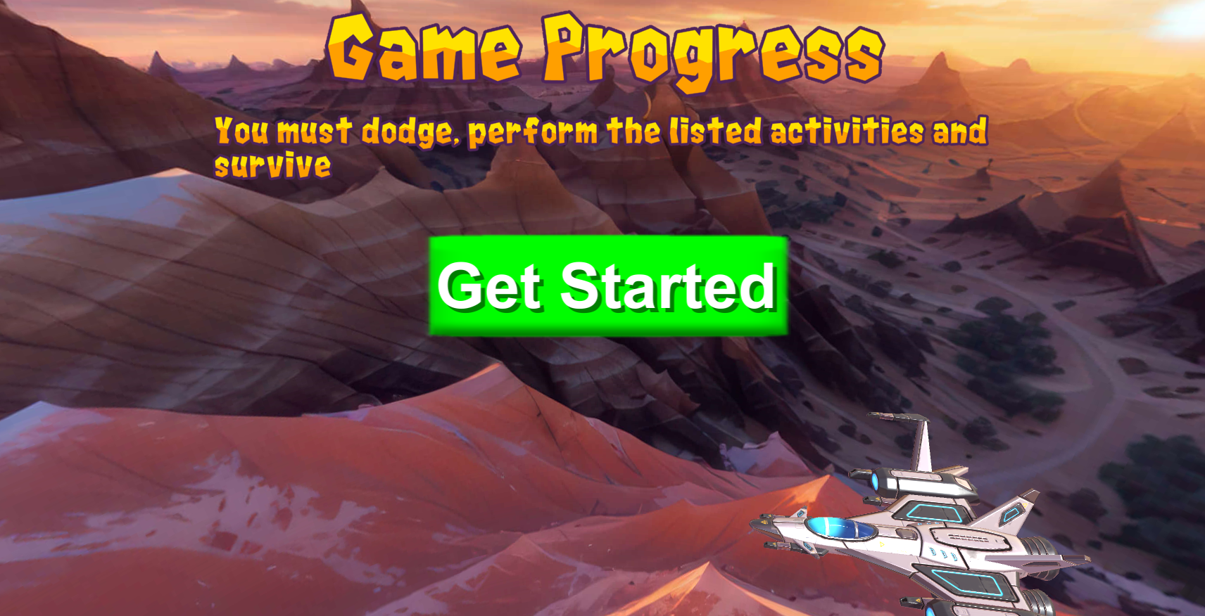

**Game Explanation Screen Description**:  
This screen introduces the game with a concise description of its objectives: **dodge obstacles**, **complete activities**, and **survive**.

**Game Explanation**:  
At the top, the game's purpose is briefly outlined to engage players and explain its benefits.

**Instructions Section**:  
Step-by-step instructions clarify how to play, focusing on dodging, completing tasks, and surviving.

**Start Button**:  
A bold "Start" button at the bottom center invites players to begin seamlessly.

The screen is clean, intuitive, and designed for a smooth onboarding experience

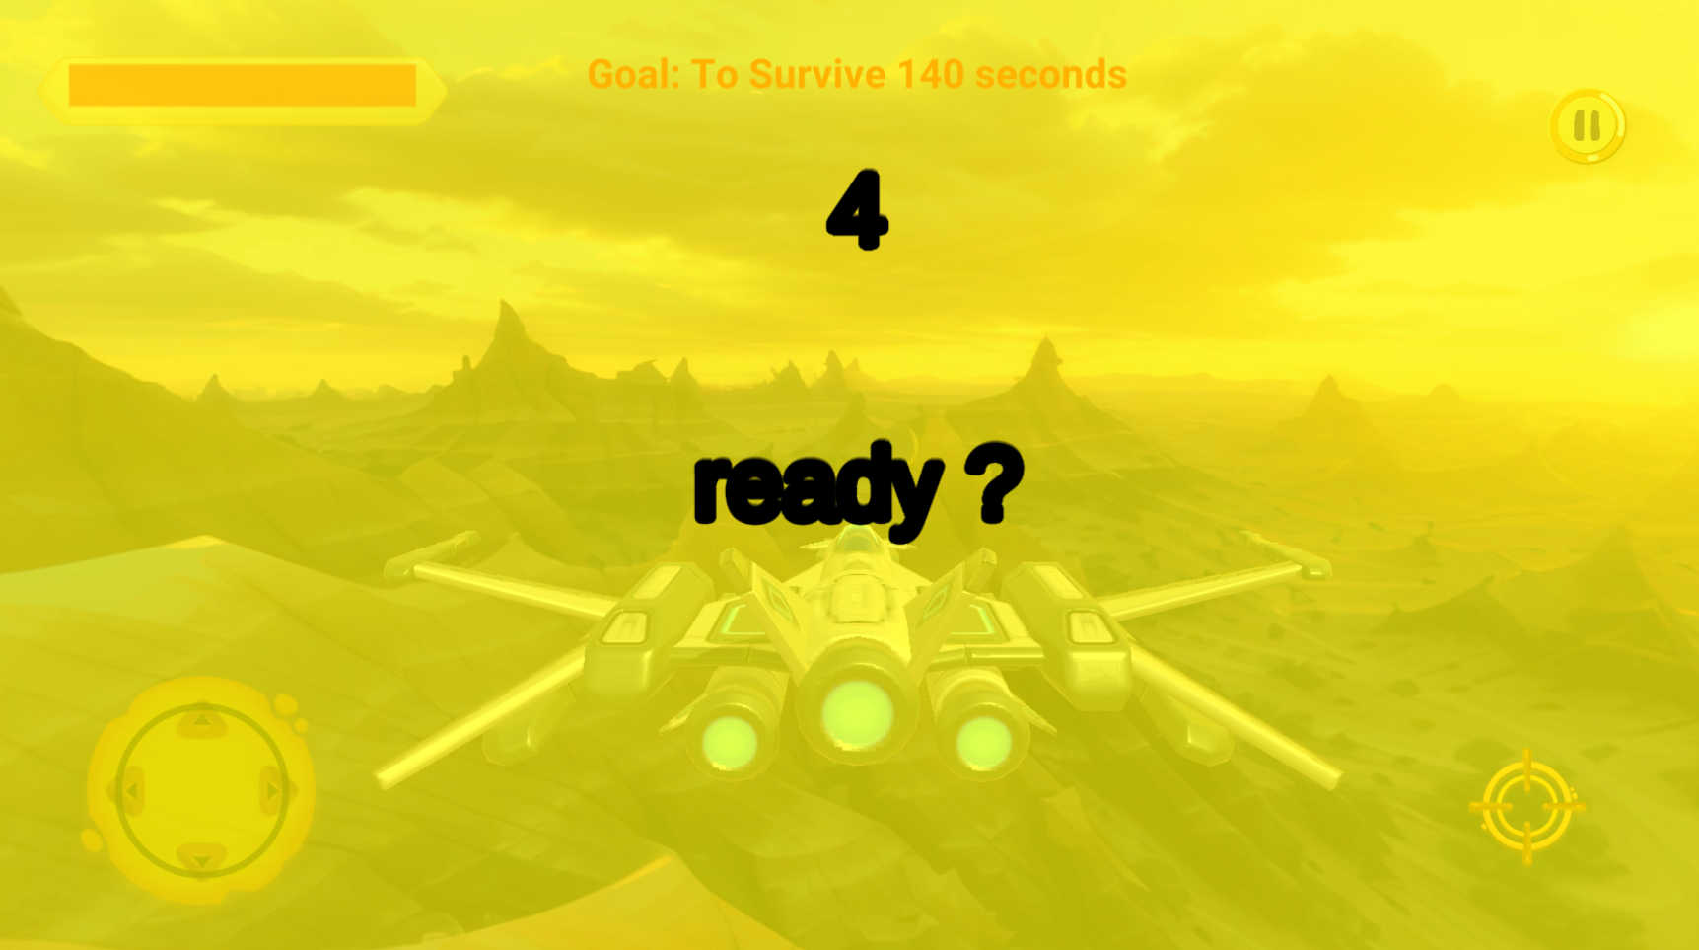

When the game starts or stops, a 5-second countdown is triggered to allow the player time to prepare and get ready for the next action.

1. **Countdown Display:**A timer appears on the screen, counting down from 5 seconds, clearly visible to the player. This countdown serves as a brief preparation period.
2. **Timing for Readiness:**The 5 seconds give the player a moment to settle in, mentally prepare, or adjust their position before the game resumes.
3. **Smooth Transition:**This feature ensures that players have a smooth transition between game states, whether starting or pausing, while also maintaining the game's flow and pace.
4. **Visual Cues:**The countdown timer could be accompanied by visual cues, such as flashing numbers or a progress bar, to enhance the player's awareness of the time left to prepare.

This mechanism improves player comfort and readiness, making sure they’re prepared for the next phase of gameplay.

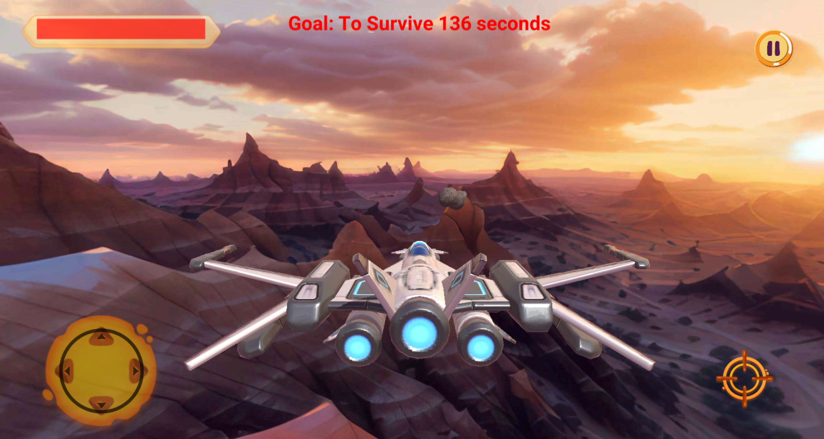

**Game Start Screen Description**:  
This screen marks the beginning of the gameplay, immersing players in an engaging and dynamic environment. Key gameplay elements are prominently displayed for an intuitive and action-packed experience.

1. **Spaceship:**  
   A spaceship is prominently featured in the center of the screen, representing the player’s character. It is the main element that players control throughout the game.
2. **Survival Timer:**  
   Positioned at the top of the screen, the survival timer tracks how long the player remains active, challenging them to survive for as long as possible.
3. **Health Bar:**  
   A health bar is displayed near the spaceship or at the top of the screen, visually indicating the player's current health level. This bar decreases as the player takes damage.
4. **Missile Fire Button:**  
   On the right-hand side of the screen, a dedicated button allows players to launch missiles. The button is clearly labeled and easy to access during gameplay.
5. **Joystick Control:**  
   On the left-hand side, a touch-based joystick enables players to rotate the spaceship in any desired direction. The joystick responds fluidly to the player’s input, allowing precise movement and control.

The overall layout is designed for seamless navigation, ensuring all controls are easily reachable, enhancing the immersive gameplay experience.

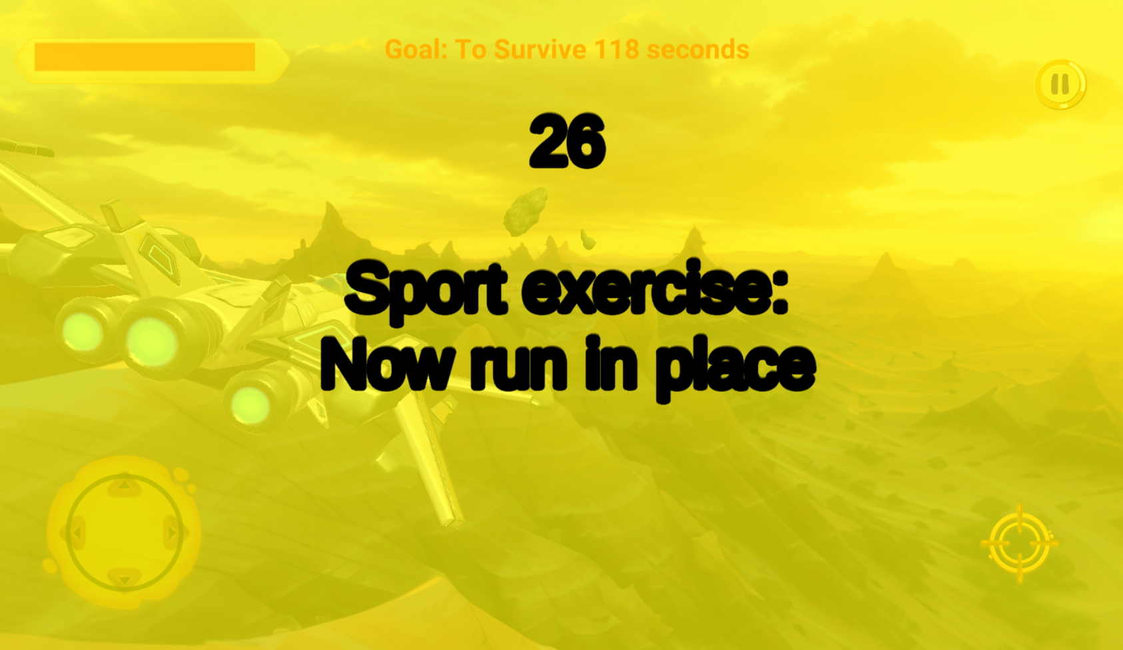

This feature introduces a dynamic pop-up messaging system designed to provide real-time instructions to the player. The first message that appears reads: **"Please run in place for 30 seconds."**

1. **Message Appearance:**  
   The pop-up is prominently displayed in the center of the screen, ensuring the player notices it immediately.
2. **Instruction Content:**  
   The text clearly instructs the player to perform a physical activity—running in place for 30 seconds—engaging them in an interactive task.
3. **Visual and Functional Design:**  
   The pop-up is designed with a clean and attention-grabbing layout, using bold fonts and possibly visual cues (like a timer or animation) to enhance the instruction's clarity.
4. **Timer Integration:**  
   A built-in timer starts counting down from 30 seconds, visually guiding the player through the activity duration.

This system seamlessly combines physical engagement with the digital gaming experience, enhancing immersion and player interaction.

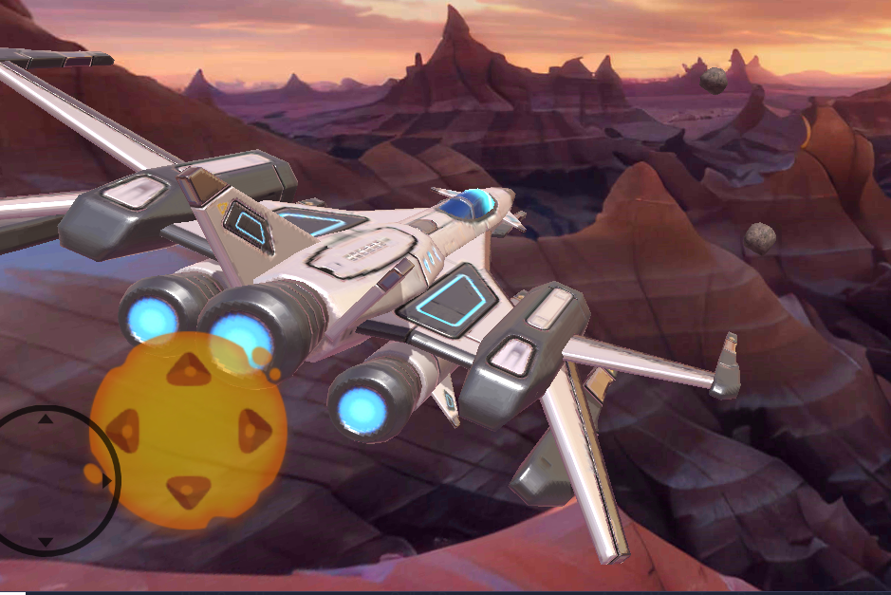

**Game Movement Screen Description**:  
This screen demonstrates the spaceship’s responsive movement controlled by the joystick. It visually reinforces the connection between player input and the spaceship's actions, enhancing the interactive experience.

1. **Joystick Interaction:**  
   When the joystick is moved to the left, the spaceship reacts by shifting smoothly to the left, reflecting precise player control.
2. **Spaceship Movement:**  
   The spaceship visibly moves to the left side of the screen, maintaining fluidity and aligning with the player's input.
3. **Visual Feedback:**  
   The joystick’s position updates dynamically, providing immediate feedback to the player as they move it. This ensures clarity and reinforces the intuitive gameplay mechanics.

This screen emphasizes the seamless control mechanics, allowing players to feel fully immersed in the game through responsive and natural movements.

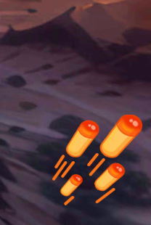

Missile Button and Targeting System Description:  
In this game, players can press the missile button located at the bottom-right of the

screen to launch missiles. The missiles can destroy objects and help the player survive. Additionally, players can aim the missiles by targeting the objects, which are highlighted in red to indicate the missile’s trajectory.

1. **Missile Button:**The missile button is clearly positioned at the bottom-right corner of the screen, making it easy to access during gameplay. It is designed for quick and intuitive use.
2. **Targeting System:**When a target is within range, it becomes highlighted in red, indicating that the missile can hit it. This visual cue helps the player align their shot before launching the missile.
3. **Missile Launch:**  
   Upon pressing the missile button, the missile is fired towards the red-highlighted target, causing destruction to the object it hits. This action helps the player clear obstacles or defeat enemies.
4. **Strategic Advantage:**The missile's precision, enhanced by the targeting system, gives players a strategic advantage, allowing them to take out threats or obstacles with greater accuracy.
5. **Visual Feedback:**When the missile hits a target, a visual explosion effect occurs, reinforcing the action's impact and success.

This feature adds depth to the gameplay, as players can actively choose targets to aim at, improving both their engagement and chances of survival.

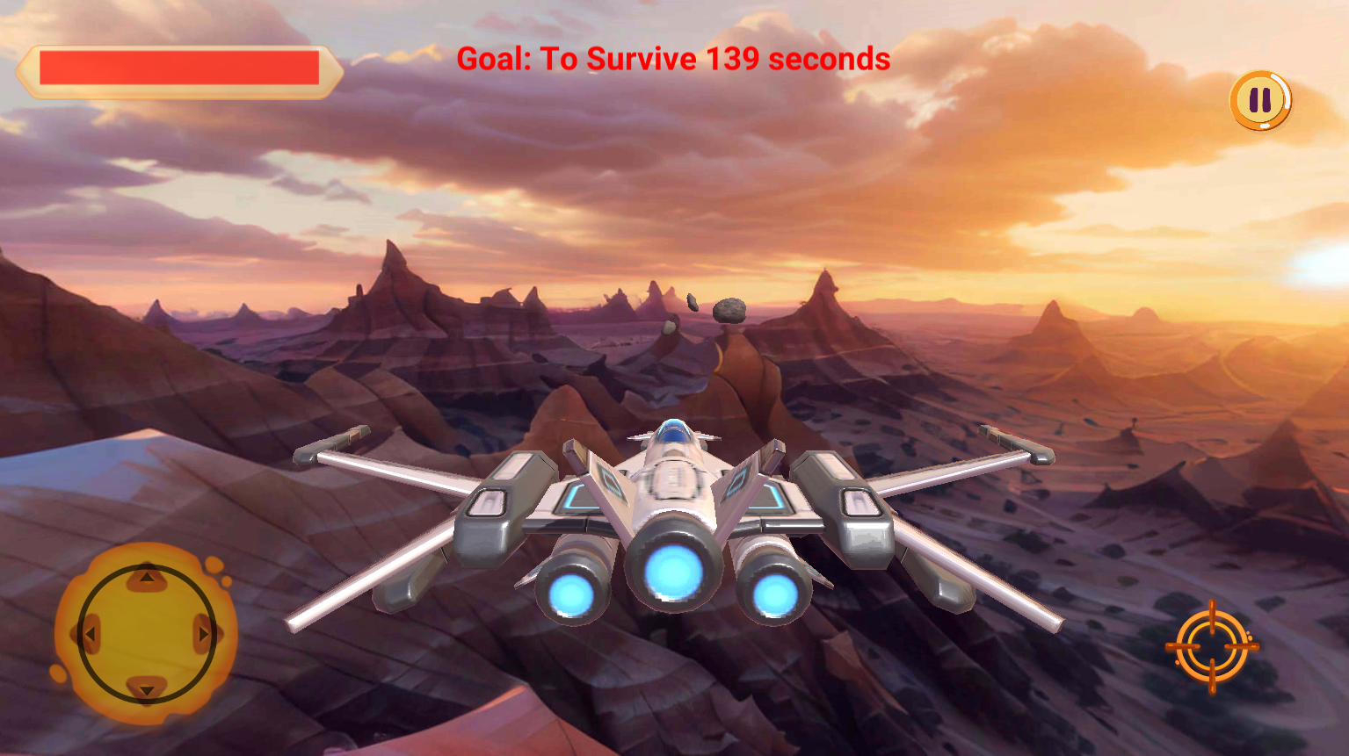



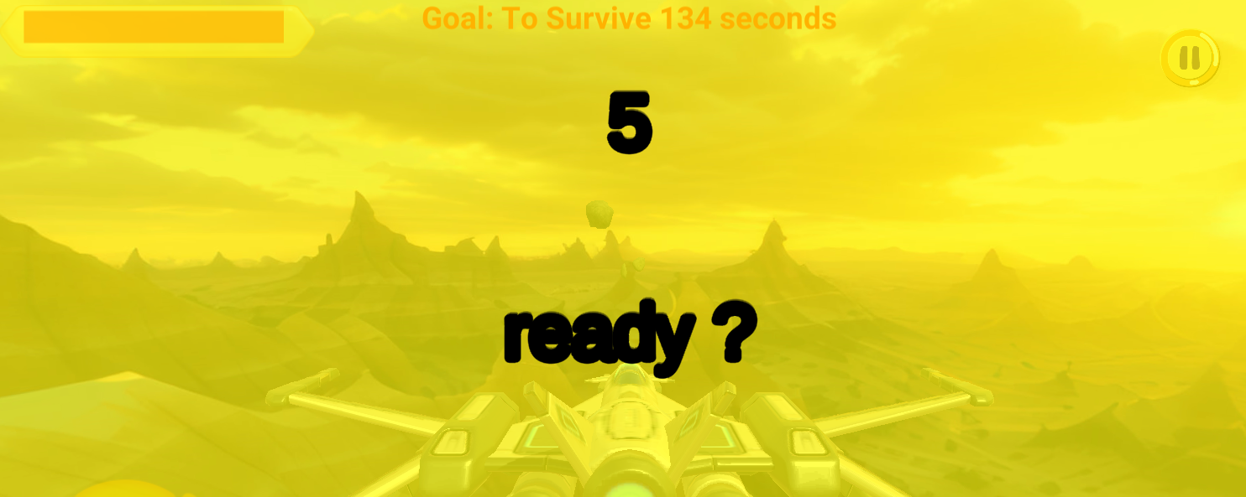

**Pause Menu and Transition Options**:  
When the game is paused, players have the option to either return to the main menu or resume gameplay. If they choose to resume, the 5-second preparation period will reappear to give players time to get ready before continuing.

1. **Return to Main Menu:**  
   From the pause menu, players can select an option to return to the main menu. This option takes them out of the current game session and allows them to access other game modes or settings.
2. **Resume Gameplay:**  
   If players choose to resume, the game will restart with a 5-second preparation period, allowing them to get ready before the action continues. This gives players time to focus and ensure they are prepared for the next phase of the game.
3. **5-Second Preparation Period:**Whether resuming after a pause or starting the game, players are given a brief 5-second period to adjust, ensuring they are prepared for the next sequence. This helps to minimize any disruption when transitioning back into the game.
4. **Visual Feedback:**  
   When resuming, a countdown timer may be shown to signal the 5-second waiting period, reinforcing that the player is preparing for the next stage of gameplay.

This functionality provides flexibility and smooth transitions, ensuring players can control their gaming experience and reorient themselves before continuing



**Spacecraft Damage and Health Bar Description**:  
In the game, the spacecraft can take damage, which is reflected in the health bar. The health bar displays the current state of the spacecraft’s health, decreasing as it sustains damage from enemies or obstacles. The game allows up to 30 hits before the spacecraft is destroyed and the game ends.

1. **Health Bar**:  
   The health bar is prominently displayed on the screen, typically near the spacecraft or at the top of the display. It visually represents the spacecraft’s remaining health and changes color as damage accumulates.
2. **Damage and Health Decrease**:  
   Each time the spacecraft is hit by an enemy or an obstacle, the health bar decreases. The number of hits the spacecraft can take is capped at 30. Once the spacecraft reaches zero health, it is destroyed, and the game ends.
3. **Health Management**:  
   Players must avoid taking too much damage to extend the gameplay. Managing the spacecraft’s health is crucial to surviving longer in the game.
4. **Visual Feedback**:  
   When the spacecraft takes damage, the health bar visibly decreases, often with a visual effect or animation to show the impact. This provides players with immediate feedback on their performance and the spacecraft’s condition.

The health bar system adds a layer of strategy to the game, as players need to be cautious and try to avoid hits to survive longer.



The game features a mechanic where the meteors decrease in size over time in a monotonic manner, while their speed increases. However, this results in a decreasing difficulty overall, as smaller meteors are easier to avoid. The combination of smaller meteors and increased speed aims to create a balanced challenge, where the player can stay focused without being overwhelmed.



**Victory Screen**:  
If the player successfully survives the game, a victory screen appears. This screen celebrates the player's achievement, displaying a clear "Victory" message along with any relevant stats, such as survival time or score. It serves as positive reinforcement, encouraging the player to feel accomplished. To prevent addiction, the game immediately exits after the victory screen, preventing the player from continuing to play.

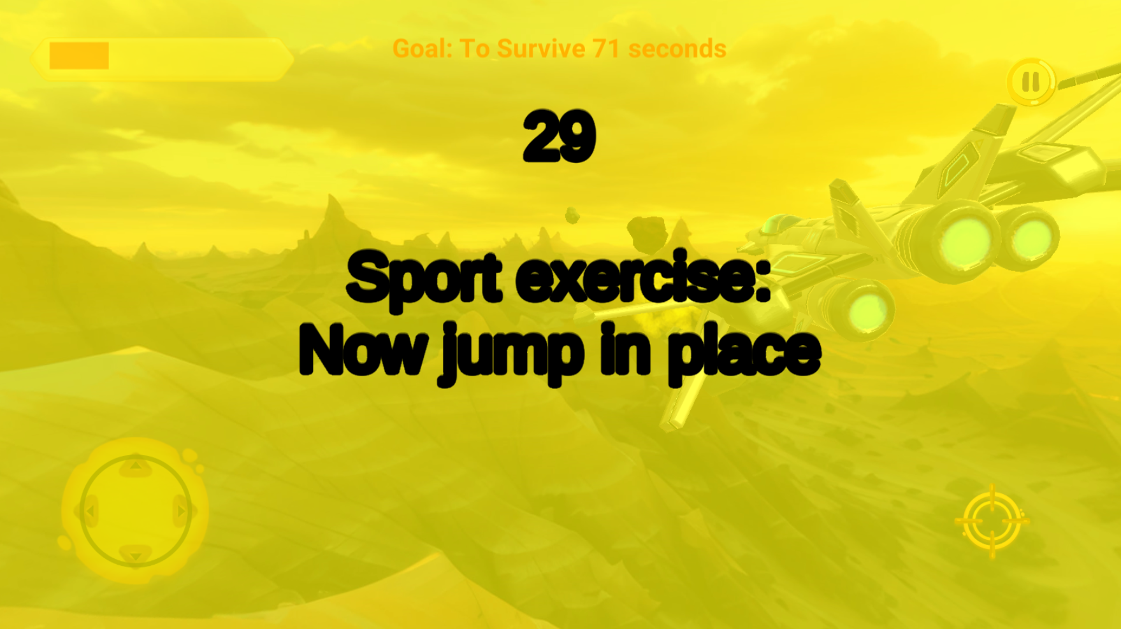

**Jumping Activity Pop-up Screen:**  
A pop-up message appears on the screen, prompting the player to jump in place for 30 seconds. This message encourages the player to engage in a brief physical activity to help improve focus and energy levels. The purpose is to get the player moving, promoting physical activity and engagement in the game. The screen includes a countdown timer for the 30 seconds, signaling the duration of the activity. After the 30 seconds, the player can resume the game.

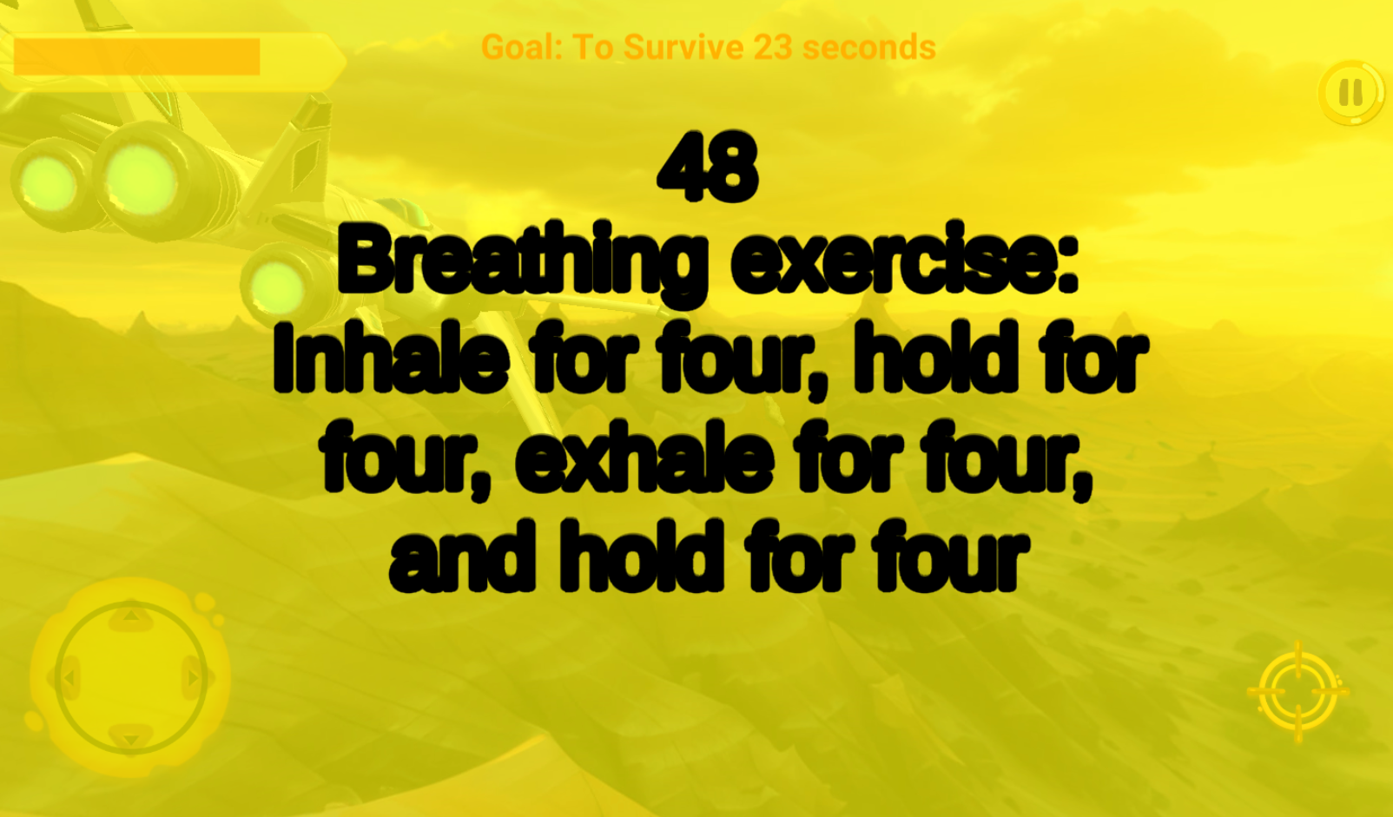

**Pop-up Meditation Activity Screen**:  
A pop-up message appears on the screen, prompting the player to engage in a 60-second meditation activity. This message encourages the player, typically a child, to take a brief break to focus on breathing and relaxation. The goal is to help the child calm down, center their thoughts, and prepare for the upcoming lesson in a relaxed and focused state. The screen includes a countdown timer for the 60 seconds, signaling the duration of the activity.

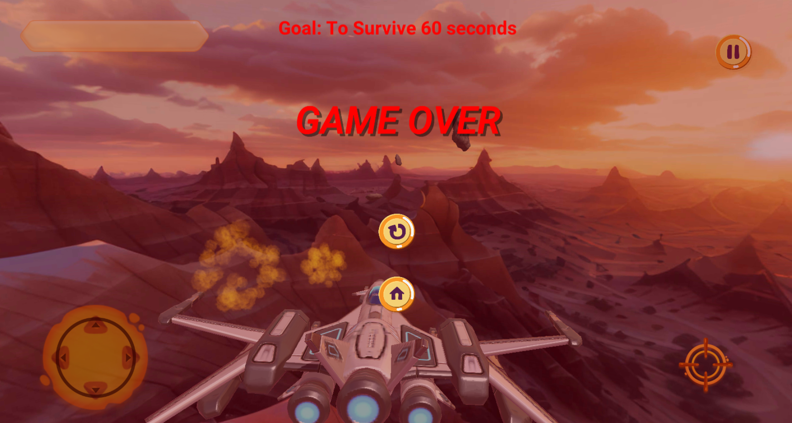

**Game Over Screen:**  
Once the player collides with 30 meteors, the game ends, and the player is disqualified. This is indicated by the health bar dropping to 0, signaling the end of the game. The screen displays a clear message of disqualification, letting the player know they have reached the maximum allowed damage. The game is over, and the player can choose to restart or exit.

**AFK Time-Out Mechanism**:  
In the game, there is an AFK (Away From Keyboard) time-out feature. If the player remains inactive on the screen without performing any actions for a specified period, the game automatically exits to prevent prolonged inactivity. This feature ensures that players remain engaged and that the game does not run unnecessarily when no interaction is happening. The inactivity period is designed to encourage active participation and avoid excessive time spent without gameplay.

# **10 Maintenance Guide Documentation**

Welcome to the “Dopamine Booster Game” Maintenance Guide.

This document provides developers with the necessary instructions to take over, maintain, and enhance the Dopamine Booster Game app. It covers setup procedures, environment configuration, build and deployment processes, and ongoing maintenance practices to ensure the app's longevity and continuous improvement.

Please note that this documentation is divided into two main sections: The first section [10.1] is intended for the general use of the mobile. The second section [10.2] is specifically designed for the game itself.

## **10.1 Dopamine Booster – Application**

**System Requirements:**

**Hardware Requirements**

* A computer capable of running the latest version of Flutter and its dependencies.
* A computer connected to the network.
* A compatible Android or iOS device for testing, or an emulator/simulator installed on the computer.

**Software Requirements**

* Flutter SDK: Latest stable version.
* Android Studio or Visual Studio Code: For Flutter development.
* Xcode: For iOS development (MacOS only).
* Git: For version control.
* Firebase: Account for backend services.
* VS Code: IDE for backend development.

**Setting Up the Development Environment**

**Flutter Installation**

1. Download Flutter from <https://flutter.dev/docs/get-started/install>
2. Follow the installation instructions for your operating system.
3. Verify the installation by running flutter doctor in the terminal to check for missing dependencies (if necessary, add Flutter to the system path manually).

**IDE Setup**

1. Install Android Studio or Visual Studio Code IDE.
2. Install Flutter and Dart plugins from the IDE’s plugin marketplace.
3. Configure the Flutter SDK path in the IDE settings.

**Clone the Repository**

git clone: <https://github.com/YuvalHilay/Dopamine-Booster-Game>

cd FlutterApp

**Dependency Installation**

flutter pub get

**Generate Localization Files:**

flutter gen-l10n.

**Building and Running the App**

Building APK file run flutter build apk –release in the terminal or flutter run for debugging.

Android: Open the project in Android Studio, select a device or emulator, and hit the Run button.

iOS: Open `ios/Runner.xcworkspace` in Xcode, select an iOS simulator or connected device and press the Run button.

## **10.2 Dopamine Booster – Game**

**System Requirements:**

**Hardware Requirements**

* A computer capable of running the latest version of Unity and its dependencies.
* A compatible Android or iOS device for testing, or an emulator/simulator installed on the computer.

**Software Requirements**

* Unity Hub
* Visual Studio: For C# development.
* Git: For version control.

**Setting Up the Development Environment**

**Unity Installation**

1. Download Unity Hub from <https://unity.com/download>.
2. Use Unity Hub to install the correct Unity Editor version.
3. Follow the installation instructions for your operating system.
4. Add Required Modules: In Unity Hub, add modules like Android/iOS/WebGL Build Support if needed.

**IDE Setup**

1. Download Visual Studio from <https://visualstudio.microsoft.com/>.
2. Include the "Game Development with Unity" workload.

**Clone the Repository**

git clone: <https://github.com/YuvalHilay/Dopamine-Booster-Game>

cd UnityGame

**Building and Running the App**

Launch Unity Hub.

Click Add Project and select the UnityGame folder.

Verify the Project: Check for errors in the Console.

Resolve missing packages via Window > Package Manager.

Reimport assets through Assets > Reimport All.

Test and Build the Game:

Click Play to test the game.

To build, go to File > Build Settings, select a platform, and click Build.

# **11 References**

1. HK Paediatric Society (2005). Clinical practice guideline: Treatment of the school-aged child with attention-deficit/hyperactivity disorder. Pediatrics, 108(4), 1033-1044.
2. Orr, J. M., Miller, R. B., & Polson, D. M. (2007). Toward a standard of care for child ADHD: Implications for marriage and family therapists. Journal of Marital and Family Therapy, 31(3), 191-205.
3. Biederman, J., & Faraone, S. V. (2005). Attention-deficit hyperactivity disorder. The Lancet, 366(9481), 237-248.
4. Stevens, J. R., et al. (2013). Side effects of stimulant medication for ADHD. Journal of the American Academy of Child & Adolescent Psychiatry, 52(3), 249-259.
5. Knouse, L. E., & Safren, S. A. (2010). Current status of cognitive behavioral therapy for adult attention-deficit hyperactivity disorder. Psychiatric Clinics of North America, 33(3), 497-509.
6. Sonuga-Barke, E. J. S., et al. (2013). Nonpharmacological interventions for ADHD: Systematic review and meta-analyses of randomized controlled trials of dietary and psychological treatments. American Journal of Psychiatry, 170(3), 275-289.
7. Kollins, S. H., et al. (2020). A novel digital intervention for actively reducing ADHD symptoms in children: Results from a randomized controlled trial. The Lancet Digital Health, 2(4), e168-e178.
8. Chacko, A., et al. (2013). Cognitive training for children with ADHD: A randomized controlled trial of Cogmed Working Memory Training and ‘paying attention in class’. Journal of Child Psychology and Psychiatry, 54(3), 309-319.
9. Cortese, S., et al. (2016). Neurofeedback for ADHD: A review of recent randomized controlled trials. Journal of Attention Disorders, 20(9), 803-811.
10. Deterding, S., et al. (2011). From game design elements to gamefulness: Defining “gamification”. Proceedings of the 15th International Academic MindTrek Conference: Envisioning Future Media Environments.
11. Koepp, M. J., et al. (1998). Evidence for striatal dopamine release during a video game. Nature, 393(6682), 266-268.
12. Volkow, N. D., et al. (2009). The dopamine system in ADHD. The American Journal of Psychiatry, 166(8), 1024-1025.
13. G. J. DuPaul, T. J. Power, A. D. Anastopoulos, and R. Reid (1998), ADHD Rating Scale-IV (ADHD-RS-IV: Home Version), APA PsycTests.

**Link to Project GitHub Repository:** [Dopamine-Booster-Game](https://github.com/YuvalHilay/Dopamine-Booster-Game)

# **12 AI-Tools**

* ChatGPT (GPT-4o by OpenAI)

Prompt 1

How can I ensure a responsive and adaptive user interface across different screen sizes and resolutions in a Flutter and Unity-based mobile app? Provide the best modern tools, practices, libraries, and techniques for handling UI scaling dynamically in both frameworks.

Prompt 2

User's Query: During my academic capstone in engineering, I would like to run an evaluation experiment testing my “Dopamine Booster Game” app in real life classroom, act as a professional researcher in order to help me understand the preparation and requirements to start and run such a complicated process.

Prompt 3

User's Query: How do I make objects move in Unity? Provide a beginner-friendly explanation of using Rigidbody, Transform.Translate(), and Vector3.Lerp() for smooth object movement.

Prompt 4:

User's Query:How can I create a pop-up message in a Unity game? Explain how to use UI elements like panels, text, and buttons to display a pop-up when triggered by an event.

Prompt 5:

User's Query:How do I implement joystick-based movement in Unity? Provide a tutorial on handling joystick input for character or object movement, covering mobile and gamepad controllers.

Prompt 6:

User's Query:How can I set up a main camera for first-person and third-person gameplay in Unity? Provide best practices for configuring camera movement, switching perspectives, and using Cinemachine for dynamic camera control.

1. LearnLM (1.5 Pro Experimental by Google)

Prompt 1

User's Query: I am a [Year] grade [Subject] teacher, I want you to create an [Subject] test for me. Test with 10 questions in order of increasing difficulty, for each question offer 4 possible answers and add a line with the correct answer for each question.

# **13 Appendix**

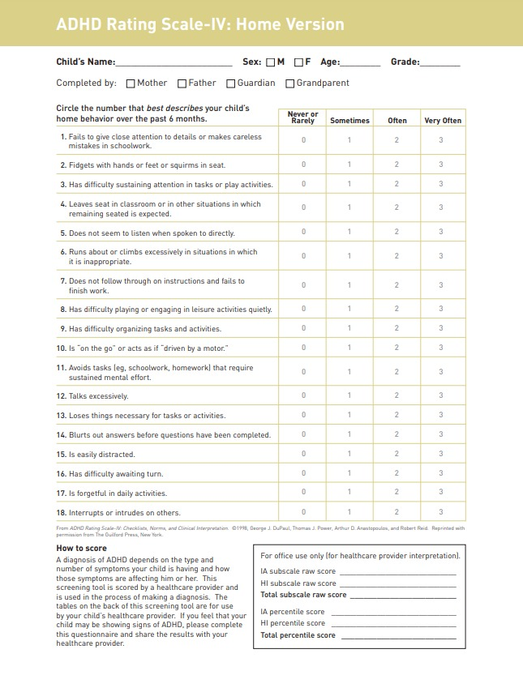Appendix A: ADHD Rating Scale IV

